StaticSpeed Vulnerability Report

As you start your final project, you are expected to perform the following tasks in BOTH Windows and Linux systems. We need to decide if StaticSpeeds systems should be integrated into NuttyUtility's extended network and infrastructure. In the end, your report must support your recommendation. This document is a template that NuttyUtility uses similar system reviews. Some specific information is provided in certain places after initial talks with NuttyUtility. Please follow the format of this template and answer all questions for each section. **You will need to provide either the text outputs from the command line and/or screenshots as evidence** in all sections of this template to show that you have completed the required steps of our company's template and make it easier for stakeholders to see where there might be issues.

Your report must include the findings of your CIS Benchmarks and Security control checks along with the results of Openvas and NMap scans. As a security professional, it is expected that you will relay your findings in terms of industry language (i.e., CVE-xxxx-xxxx, Mitre Technique ID Txxx where applicable). Based on NuttyUtility's security policies, are these systems ready? Your report will be used by stakeholders to decide on the integration.

The best way to find these vulnerabilities is by performing vulnerability scans using Nmap NSE Vuln scripts as shown in the course Nmap lesson and use the CIS benchmarks requested in the project.

**Control checks and CIS benchmarks for Windows & Ubuntu**

In this section, outline your answers from the requested checks. Please provide either the **command-line outputs in the form of text** or **screenshots** that show a CIS check and/or control check has been performed. You must also answer the questions based on your assessments.

## Step 1: Asset identification, address update, dependencies, patches, and native protections at targeted Server/ Desktop Operating Systems

### **Task 1**

As seen in your lessons, you must have CIS Benchmarks for Ubuntu 18.04 v2.01 and Windows 10 Ent v1.9.0 to perform these checks. Use the MITRE website for the database of common vulnerabilities and exposures (CVE) [https://cve.mitre.org](https://cve.mitre.org/) and Mitre ATT&CK framework for referencing attack techniques, tools, and procedures attack.mitre.org.

You must download the CIS Benchmark PDFs for Ubuntu 18.04 v2.01 and Windows 10 Ent v1.9.0. In these PDFs, there will be all the information related to the CIS Benchmarks requested in the following tasks which need to be included in your final report. In order to perform the vulnerability scans via Nmap NSE scripts as shown in Lesson 6 “Use Nmap for Vulnerability Discovery“ Please review the lesson if needed and use, as suggested in the Lesson NSE scripts from [Vulscan](https://github.com/scipag/vulscan) and [Vulners](https://github.com/vulnersCom/nmap-vulners.git) GitHub repositories. Using these NSE scripts should be enough to discover the vulnerabilities present in your virtual machines (Both Ubuntu and Windows Machines). Both machines have vulnerable services and applications, a vulnerability may include as well, a deprecated or outdated/exposed service, it is also suggested to use the highest privilege (root/administrator) when applicable to perform an audit, there might be applications not found by network scan yet present at machines that are also reportable (Please review Lesson 2 “Software Inventory and Version Tracking”).

Once you discover the vulnerabilities please refer to Mitre cve.mitre.org for vulnerability classification and remediation, also Mitre ATT&CK framework attack.mitre.org (Lesson 2, “Identify Industry Frameworks for Vulnerability Reference Pt 1“) to get things such as technique ids, tools, and procedures. Once you have all this information, you will need to complete the report template. Your report Must also include the CIS Benchmarks requested in the next tasks please see template examples for the report format.

### **Task 2**

Let's get started on our assessment. We need to find out if software updates and third-party packages settings are correct. Verify in both of your hosts the following checks.

Are software updates for the systems and third parties configured correctly in these systems?

What is your assessment of StaticSpeeds systems configuration for software updates and third-party packages? Please provide evidence to support your evaluation (command line output or screenshots for each as well)

**Windows CIS 18.9.102.2**

Ensure 'configure automatic updates' is set to 'Enabled.'

The configuration was disabled, which is not correct.

third-party updates must be disabled or with a value of 0

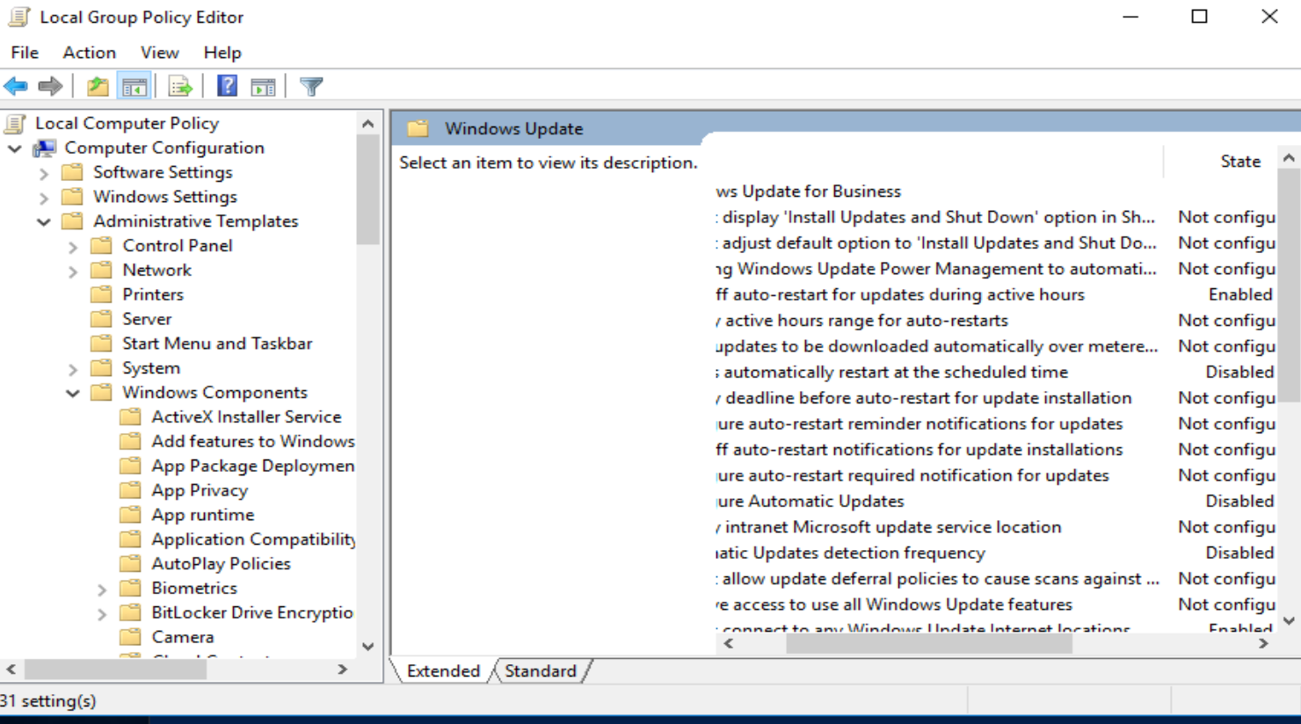

I enabled the automatic updates as can be seen in the screenshot below.

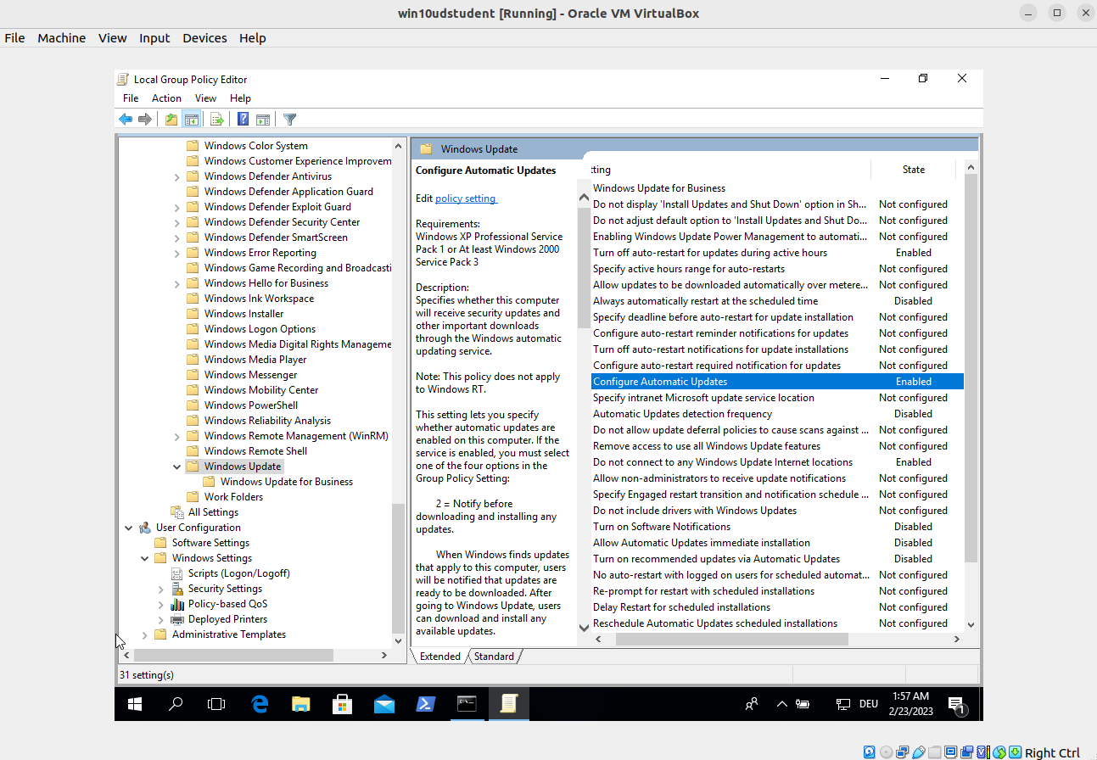

**Ubuntu CIS 1.2.1**

Ensure package manager repositories are configured correctly.

It can be seen that the updates in ubuntu seem to be good.

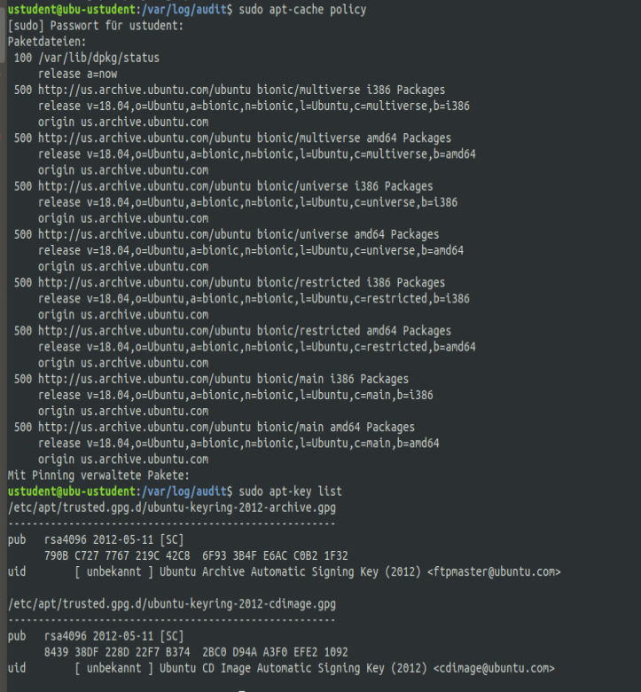

### **Task 3- Native Protections and Software Inventory**

Next, verify that native protections for the operating systems are enough to protect systems from exploitation. (Hint: Think upgrades) We also need to know exactly what software is running on every machine. Also, please perform a software inventory on each computer and post your findings. The more you know about the systems you are defending, the better chance you will mitigate and harden them.

Provide documentation as to what applications are installed on the Windows machine.

**Windows CIS 18.3.4**

Ensure 'Enable Structured Exception Handling Overwrite Protection (SEHOP)' is set to 'Enabled.'

Is this system compliant?

It is not CIS complement. The path from the CIS does not exist. An additional Group Policy template is required to add MS Security Guide.

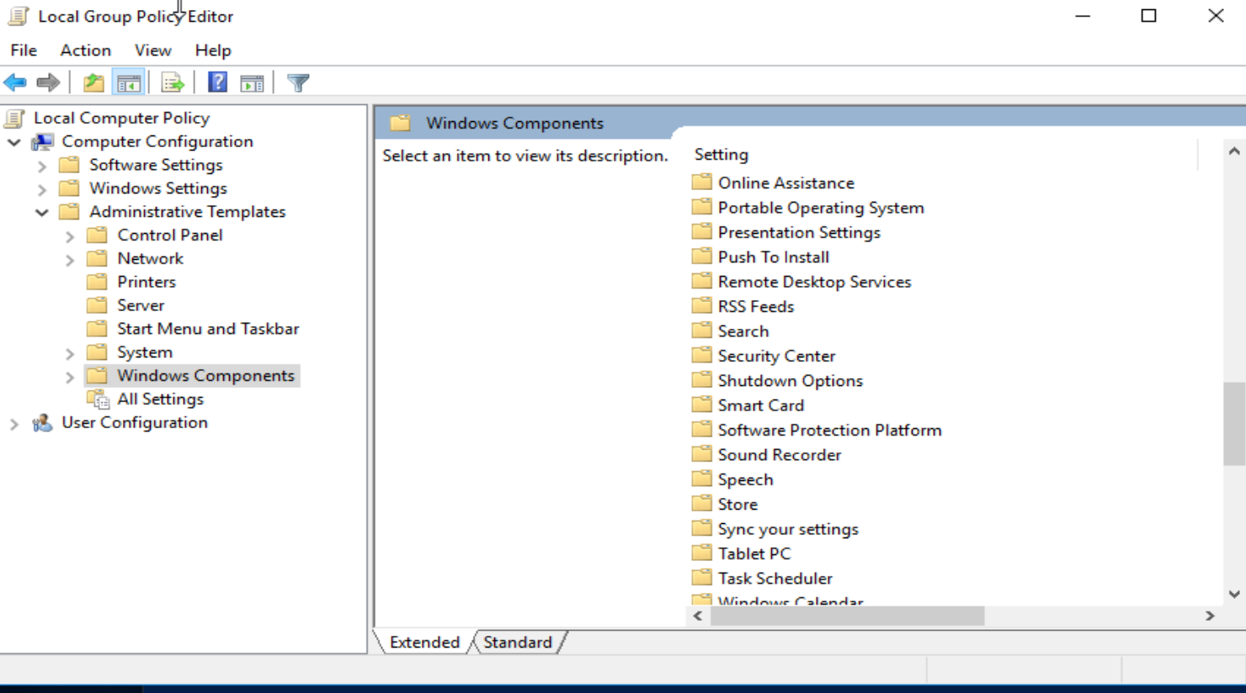

The registry entry DisableExceptionChainValidationis not available.

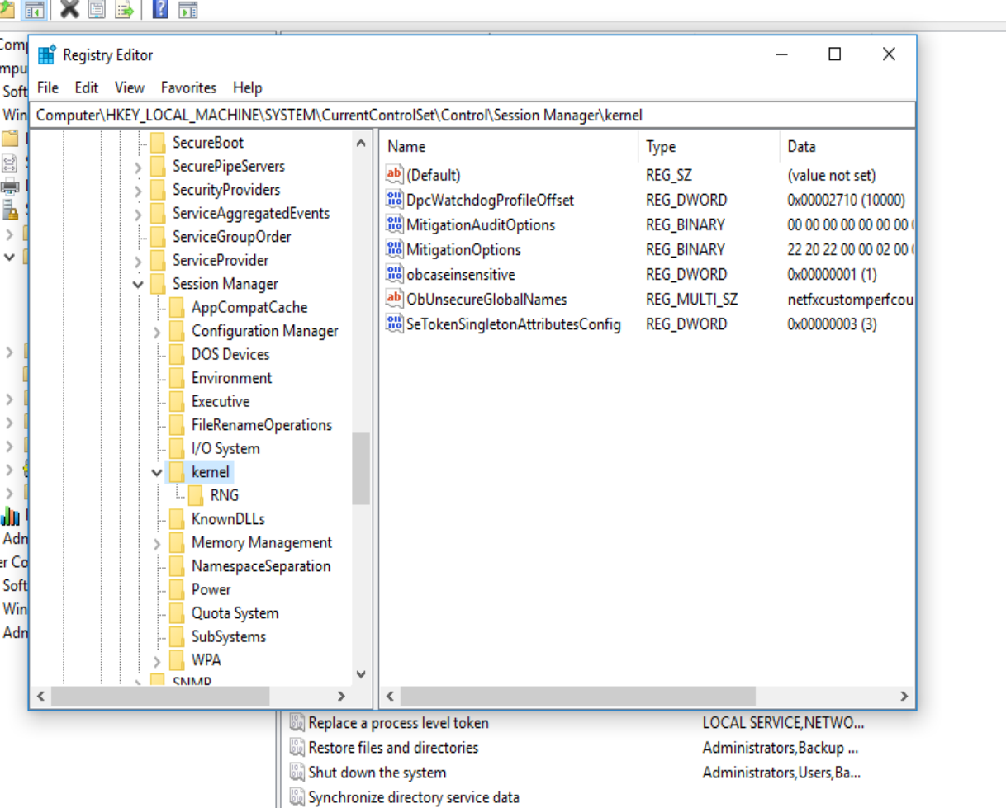

**Ubuntu CIS 1.6.1, 1.6.2**

1.6.1 Ensure XD/NX support is enabled

The system is CIS conform

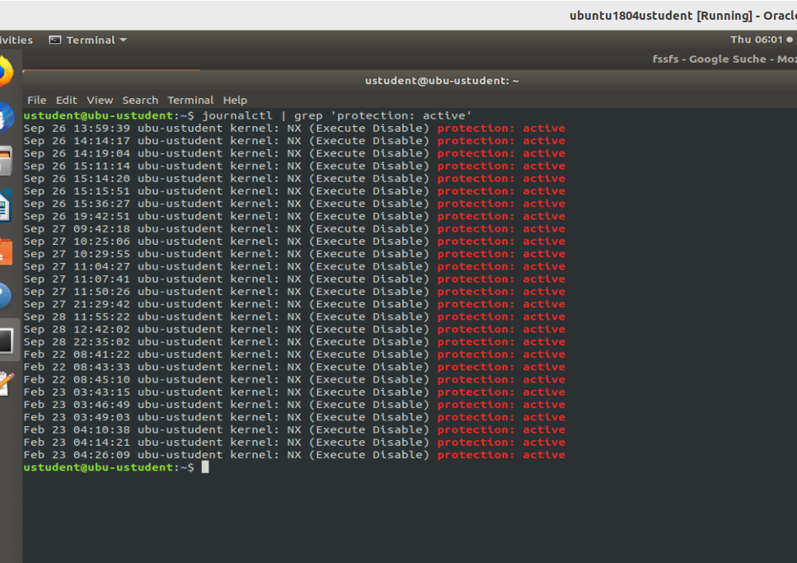

1.6.2 Ensure address space layout randomization (ASLR) is enabled

The system is not CIS conform. It needs to set the kernel.randomize_va_space=2 entry in the *etc*/sysctl.conf

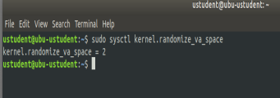

Please provide proof of checks via command output or screenshots. According to these checks, are native protections applied to these systems? What packages are installed in this ubuntu machine?

All the installed packages can be viewed in ubuntu with apt list –installed

Is TightVNC installed on this Ubuntu machine?

Yes, TightVNC is installed

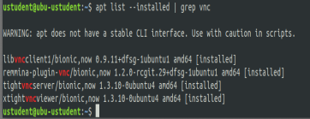

Do these applications, both for Windows and Ubuntu, bring added risks to these systems? Please provide proof and reasoning for your answer.

Yes, every additional installed application increases the attack surface and thus increases the risk.

For example on ubuntu is an ftp server running which sends username/password in cleartext which can be intercepted by a man in the middle attack. This service should be deactivated. In general the number of services should be kept to a minimum.

The programs in windows can be checked by going to settings > Apps & features. It lists for example VNC Viewer, TightVNC, Putty

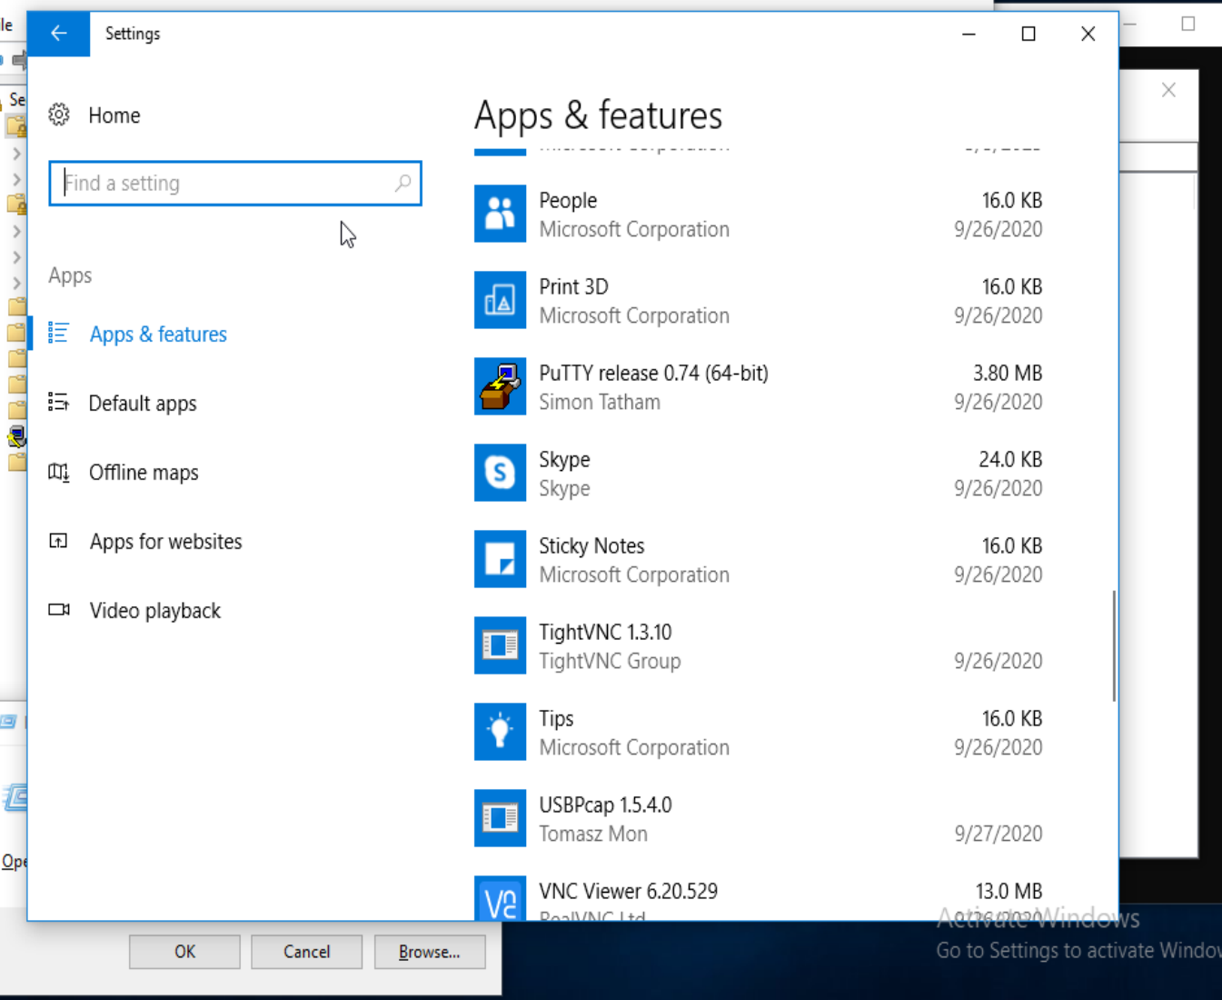

### **Task 4**

Perform a network asset inventory using Nmap to identify VMs with open ports on both Windows and Linux

What is your assessment of the Asset Inventory and what recommendations do you have to mitigate any potential issues. Please provide evidence to support your findings.

**Ubuntu**

**Ports should be disabled:**

Port 12/tcp daytime service

Port 17/tcp qotd

Port 21/tcp ftp

Port 23/telnet

**Ports that are fine:**

Port 22/ssh

Port 37/tcp time

Port 80/tcp http

Port 139/tcp samba

Port 445/tcp samba

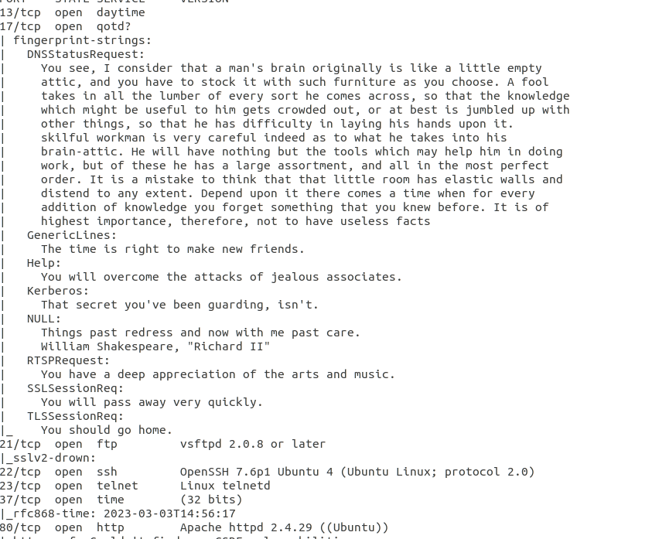

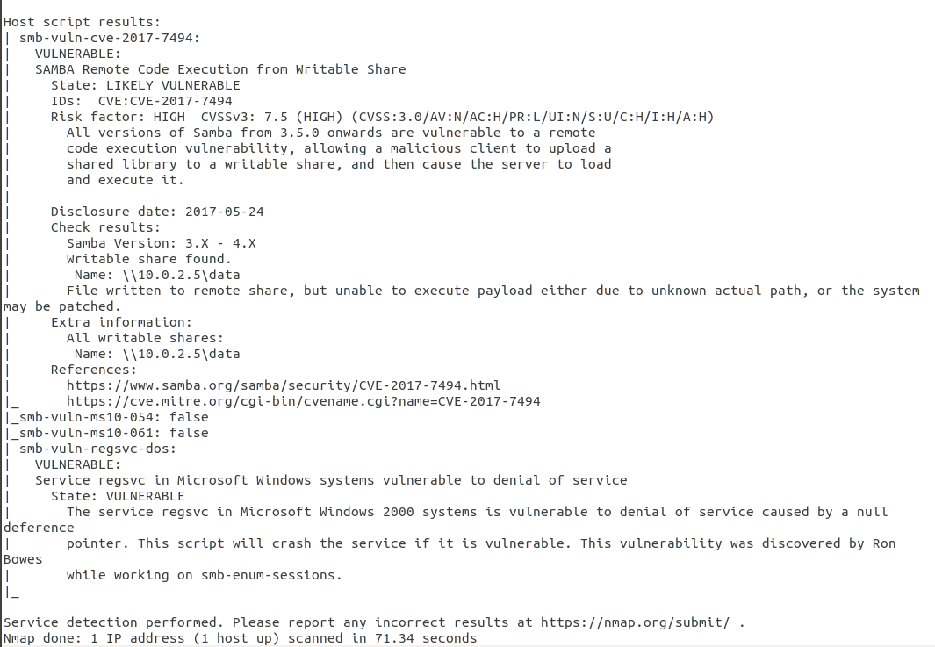

**Windows ip**

**Should be disabled**

7/tcp echo

9/tcp discard

13/tcp daytime

17/tcp qotd

19/tcp chargen

**Are good:**

135/tcp msrpc

139/ microsoft ssn

445/tcp microsoft ds

3389/tcp ms wbt server

80/tcp http

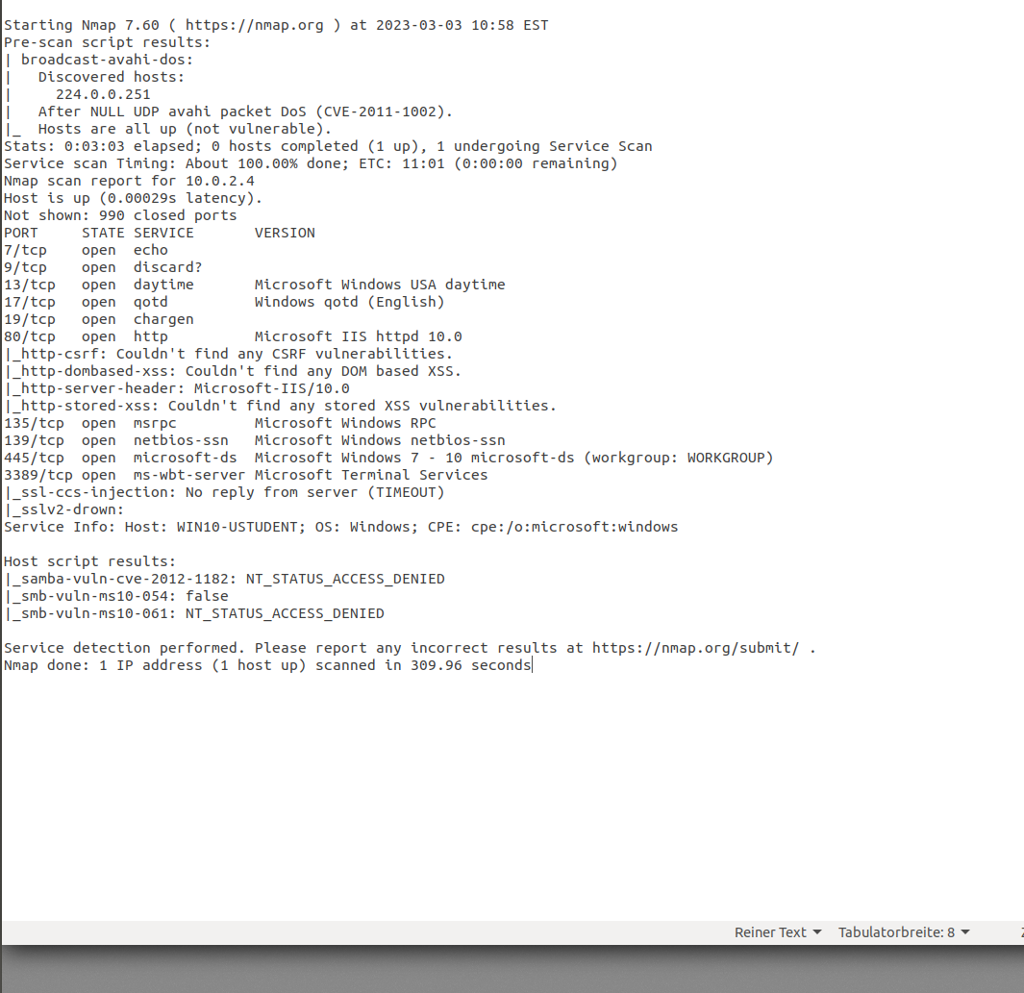

## Step 2: Assess Access Management at Targeted Assets

### **Task 1**

Check for current settings on Network Segmentation, VLANs, Domain Isolation, or IP Security Policies.

After completing your checks, what is your assessment of these settings? What recommendations do you have to improve the settings? Remember to provide evidence to back up your thoughts. Things to consider on both Ubuntu and Windows:

* Are there any VLANs?
* Are there any policies in place?
  + If there are any, are they applied?
* Is Anonymous access granted to any share?

VLAN hints:

Ubuntu: look under /etc/network/interfaces

Windows: Look under properties of network adapter or Cmdlet Get-NetAdapter|Format-List*, secpol.msc (please provide screenshots)

Vlans:

There are no vlans configured in ubuntu

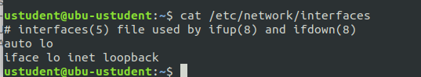

There is no vlan configured in windows

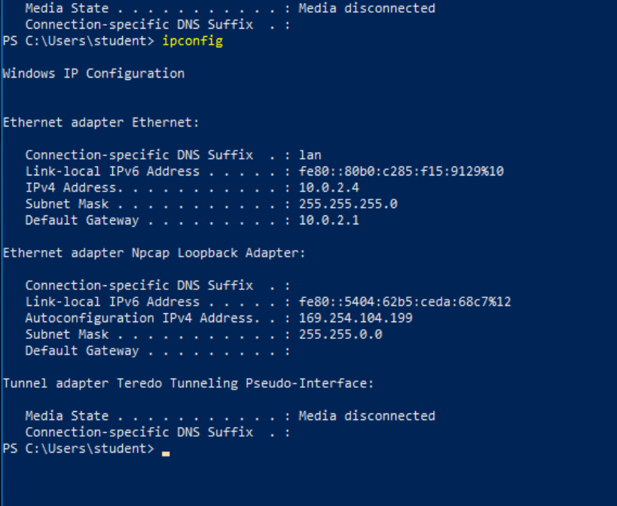

The network adapter is able to handle vlan

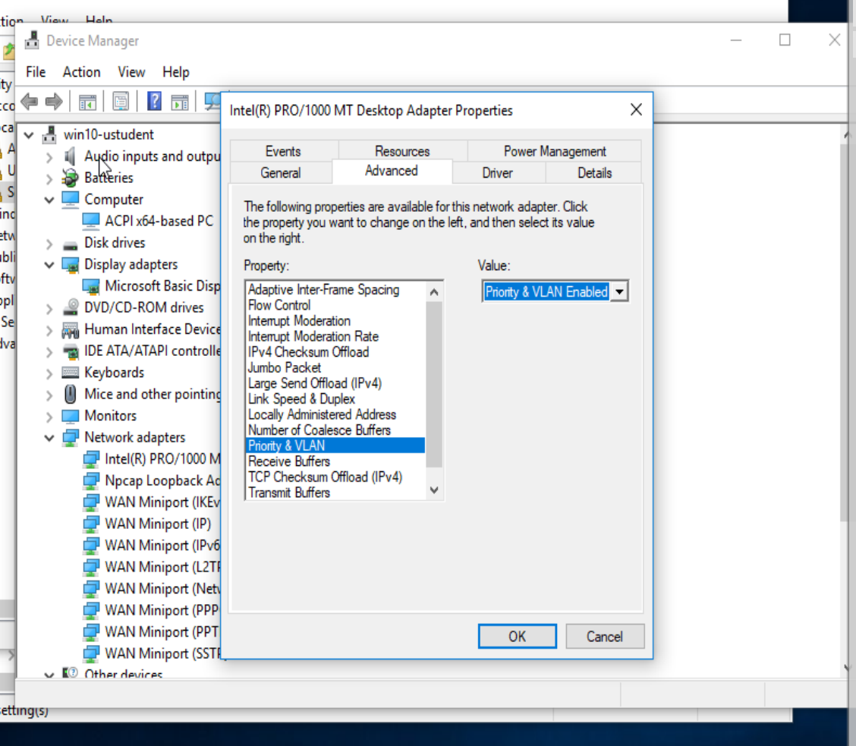

On windows there is an IPSec in place, but not applied. See screenshot below.

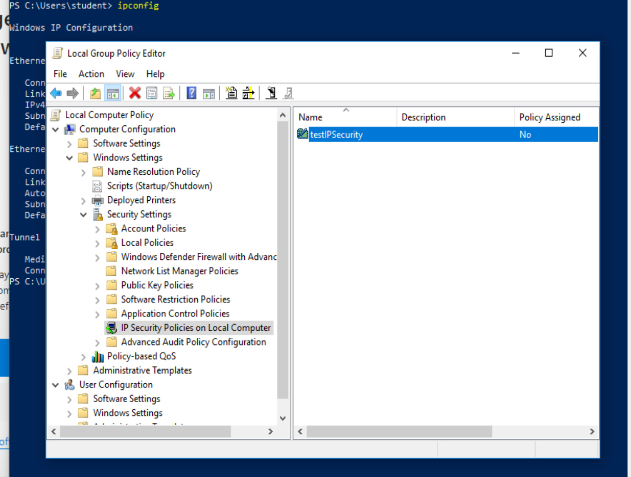

There are no policies configured in ubuntu

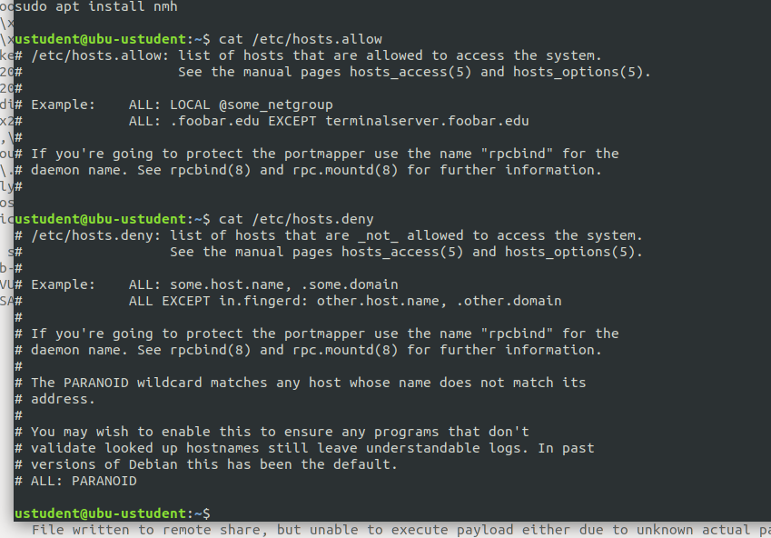

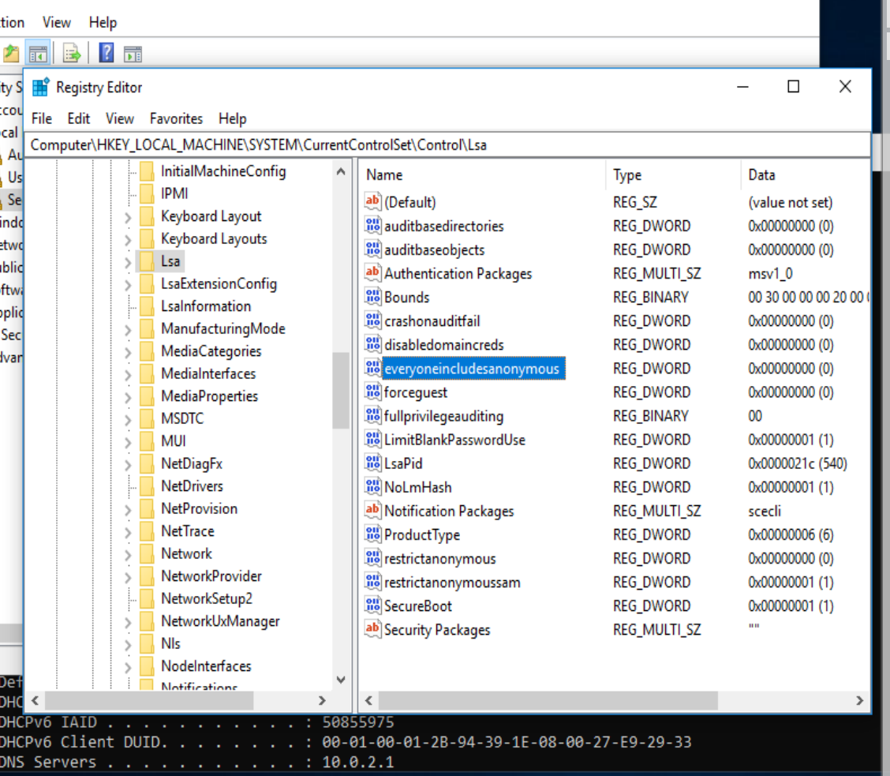

Access by anonymous users is restricted

The network should be made more secure by adding vlans to separate the networks. There could be different vlans for different departments and especially for guest access.

### **Task 2**

Investigate and assess the remote access services and protocols in place for StaticSpeed and determine their security level. After completing your investigation, including your assessment of how StaticSpeed is doing with remote access. Please have evidence to support your findings. Remember to consider IPv4 and IPv6. Also, include which Remote Service protocols are running on these systems (both Ubuntu and Windows)? What would you recommend to make improvements to this system? Are there protocols that should not be enabled?. Are there networking features that should be disabled or hardened?

One hardening possibiltiy for ssh would be to permit root access only when an internal ip adress is used, denying access from the outside.

Services that are not used or more unsecure, like ftp should be disabled.  
In general it would be good to disable ipv6 as it is not necessarily used and then only ipv4 needs to be secured. This saves a lot of effort and reduces the attack surface.

The ftp service should be completely shut down as it is a unsecured protocol.

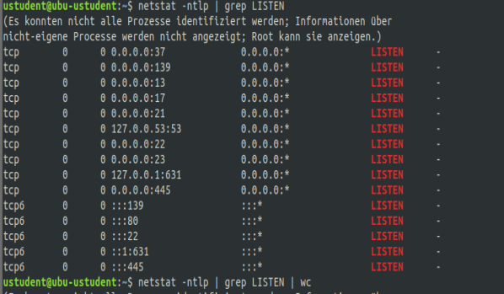

Windows ipv4

Should be disabled

7/tcp echo

9/tcp discard

13/tcp daytime

17/tcp qotd

19/tcp chargen

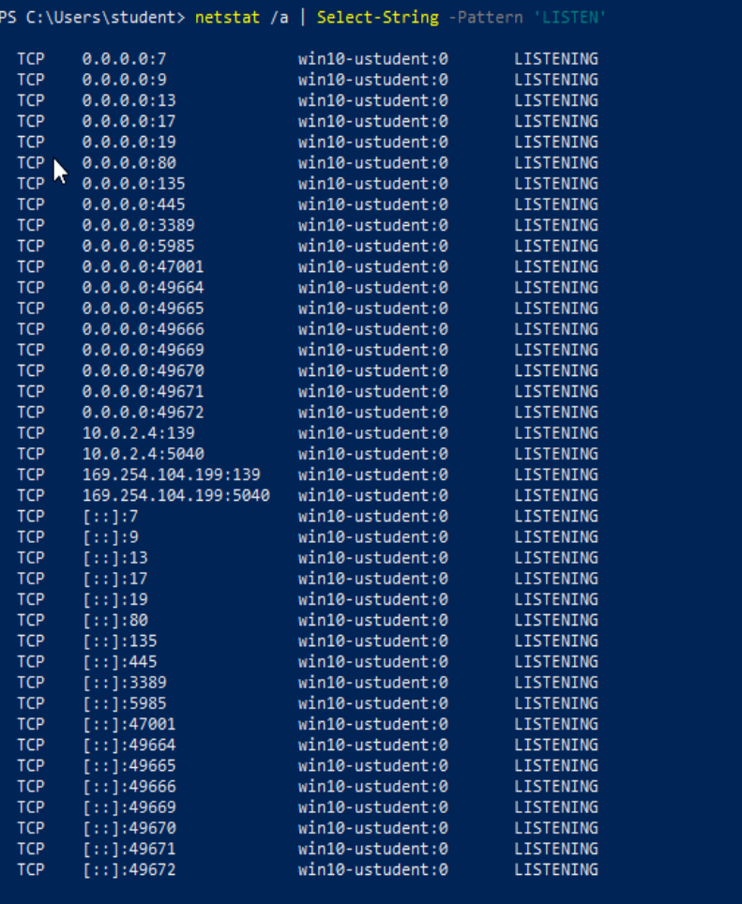

### **Task 3**

NuttyUtility only needs remote access ports for administrators on workstations. What is your assessment of the firewalls in StaticSpeed's systems? Please include evidence to support your thoughts. We need to know if the firewalls are configured correctly?

Also, what ports would you suggest to have open and running and why?

In ubuntu the firewall is inactive

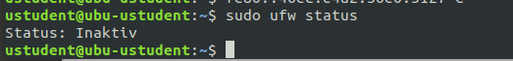

### I would suggest that port 22/tcp is open for the ssh service that admins can remotely log into the workstation. Additionally, I would permit access only with an internal ip adress.

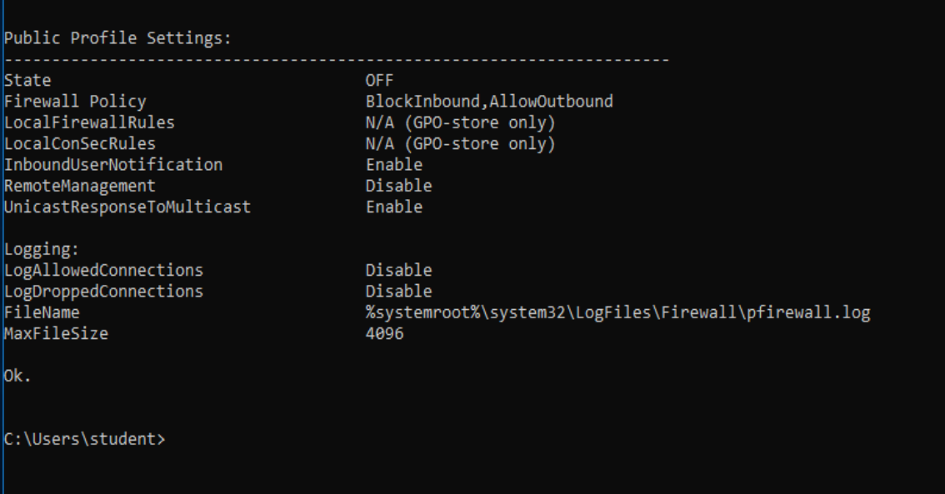

### 

### **Task 4**

Next, conduct a Principles of Least Privilege assessment of StaticSpeed's system. We need to know:

* Which users have high privileges?
* Do important PII folders have the correct permissions and ownership?
* Are the default settings correct, and are there any excessive permissions?
* On our initial scan, we found "data" shared folders that need further investigation.
* Are there "guest" accounts enabled? Are they allowed to use Sudo commands? Are they allowed to log in to ALL workstations?.

Based on your findings, what should be done to secure these accounts and permissions better? Please provide proof of your results and provide reasoning for your answer.

In ubutu the folder permissions are not set correctly as everyone has read, write and execute permission to the data folder for example.

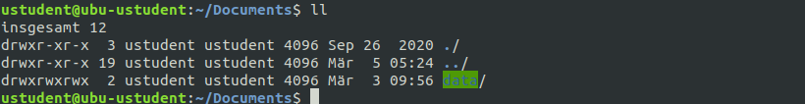

On ubuntu there are guest accounts



On ubuntu everyone is allowed to use sudo.

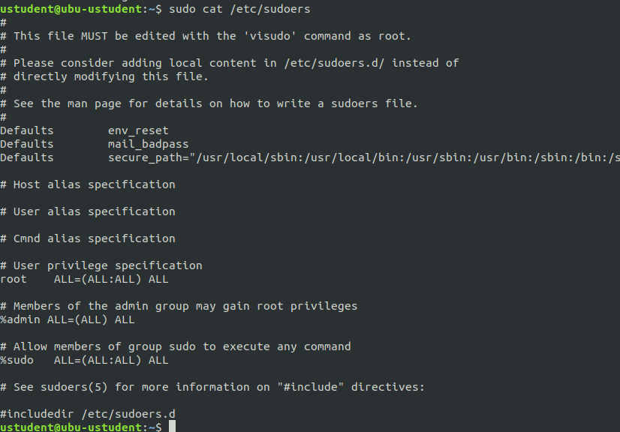

**On windows**

There are guest accounts

## The permissions are not set correctly as everyone has full control over the data folder.

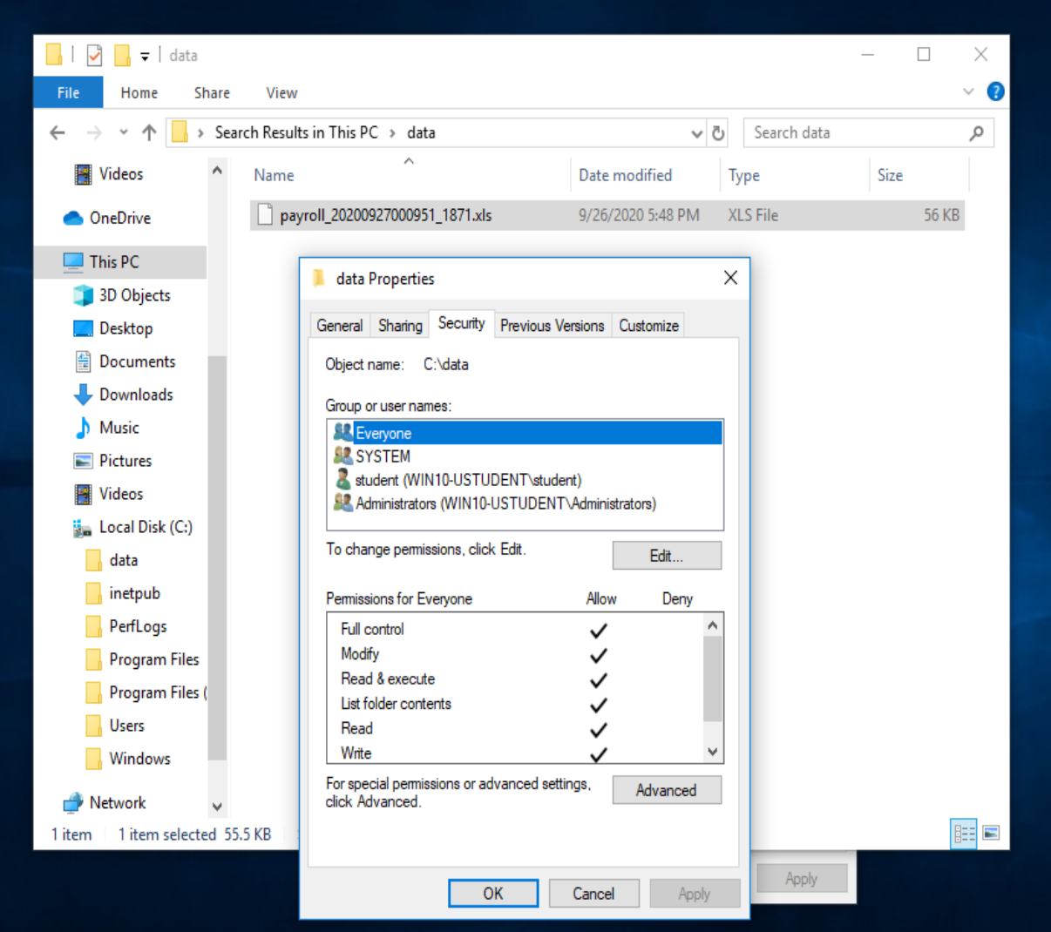

## Step 3: Log Monitoring Setup for Detection at Targeted Assets

StaticSpeed has provided access to a monitoring device that has recorded some traffic marked as malicious. Please investigate and assess this further using Wireshark or tcpdump and the provided capture files (pcaps). It is also required of you to verify that appropriate logging is in place at your machines.

Complete your assessment of this traffic. Then, add your suggestions on any issues and improvements by following the steps below. Remember to provide evidence to support your work and recommendations.

### **Task 1**

In this audit, use the pcaps named bruteforce2.pcap and lateralmovement.pcap, along with the other pcaps that may provide more insight into StaticSpeed's network. We recommend focusing on bruteforce2.pcap.

The snapshot below shows the list of pcap files present in both machines.

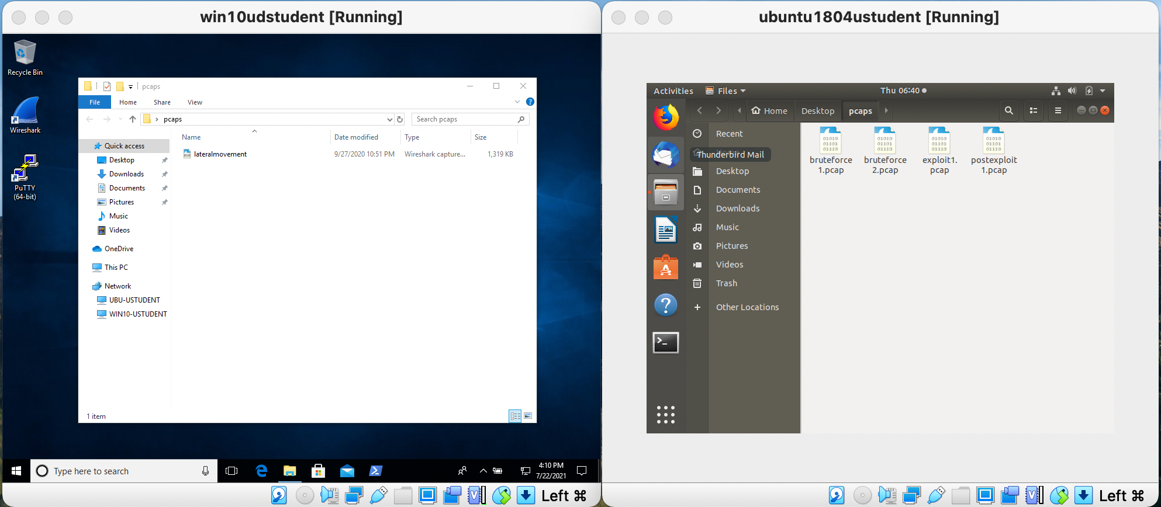

Use the pcap file to assess and determine the following:

* What type of attack was recorded?
* What is the source IP of the attack?
* What protocol was targeted?
* What password was used successfully?
* Which user was compromised?

Based on your findings from above, what is your assessment of what happened? Please provide evidence to back up your results.

There was a bruteforce attack from the host 10.0.2.7. This can be seen that request with different username/password combinations are recorded.

The telnet protocol was targeted.

The successful credentials are: ustudent/1234 as seen in the last screenshot.

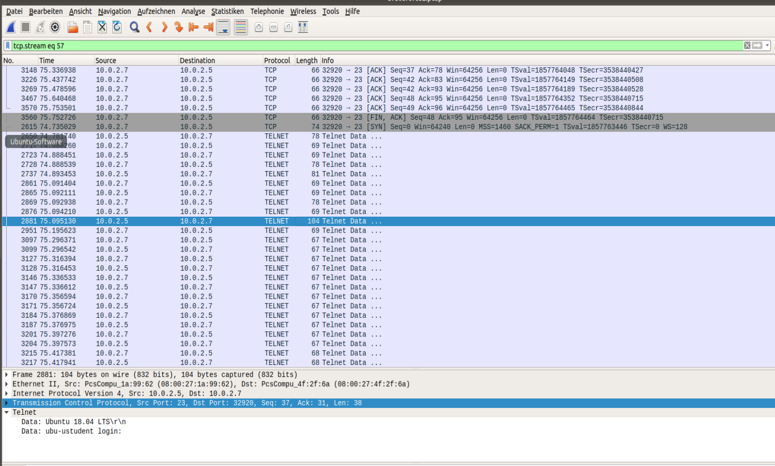

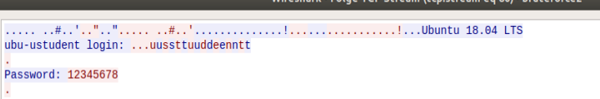

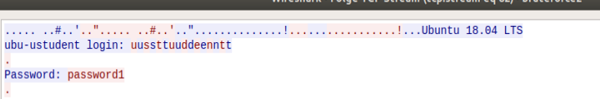

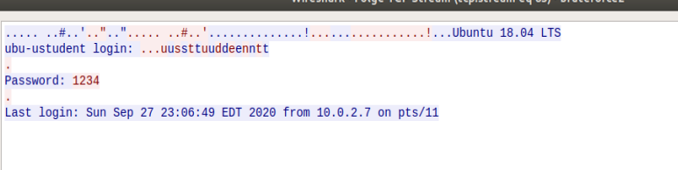

Bruteforce attacks can be prevented by using timeouts that slow down the attack. Futhermore, the quality of the password should be extended. It should be longer and have small and big letters as well as special characters.

### **Task 2**

We suspect that an internal user may have compromised another machine inside StaticSpeed's network and pivoted to one of the devices you are auditing. Please use lateralmovement.pcap and determine the following:

* What was the source IP of the "initial" attack?
* Did the attacker try to access your machine from a compromised device - MITRE ATT&CK Technique T1021?
* What service and port were targeted?
* Was the attacker able to access a sensitive file at the machine you are auditing? Mitre ATT&ACK Technique - T1570

Please provide a narrative of what happened based on your findings. Justify your report based on the answers.

The source ip of the initial attack is 10.0.2.7.

It seems the attacker also attacked the machine 10.0.2.6.

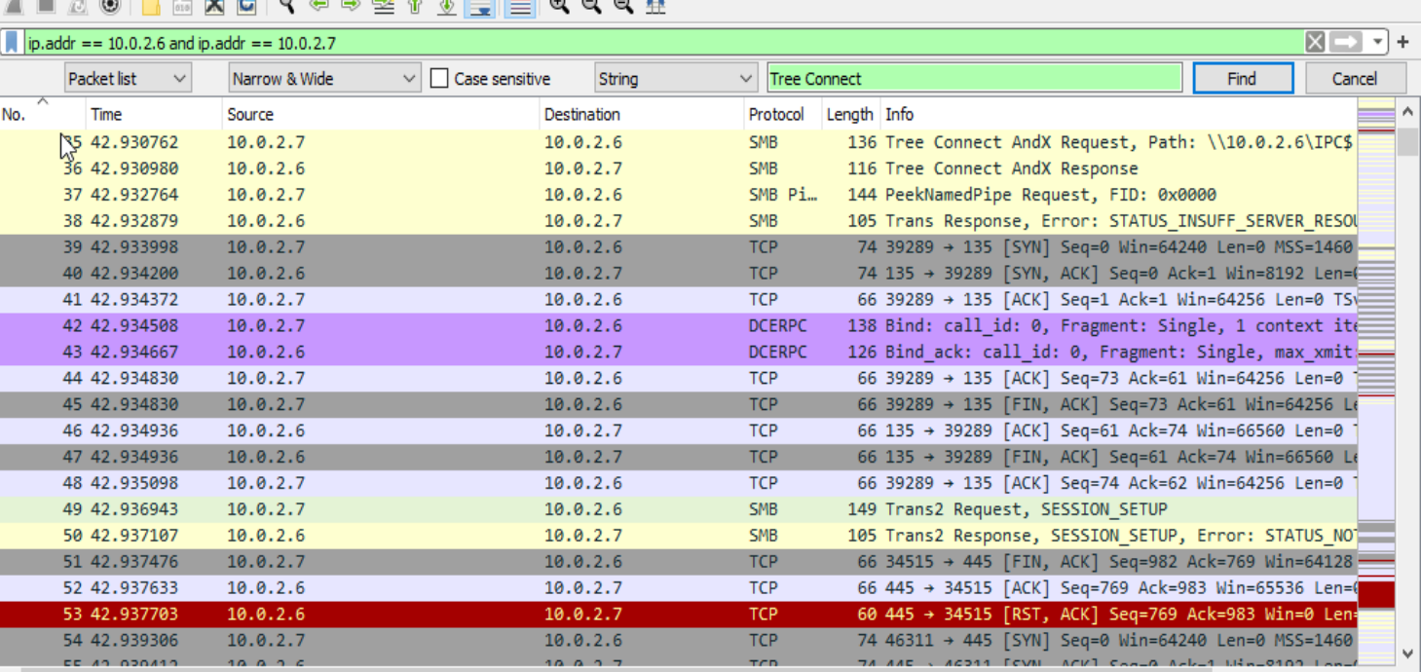

The attacker tried to access my machine 10.0.2.4 from a compromised machine with ip 10.0.2.6.

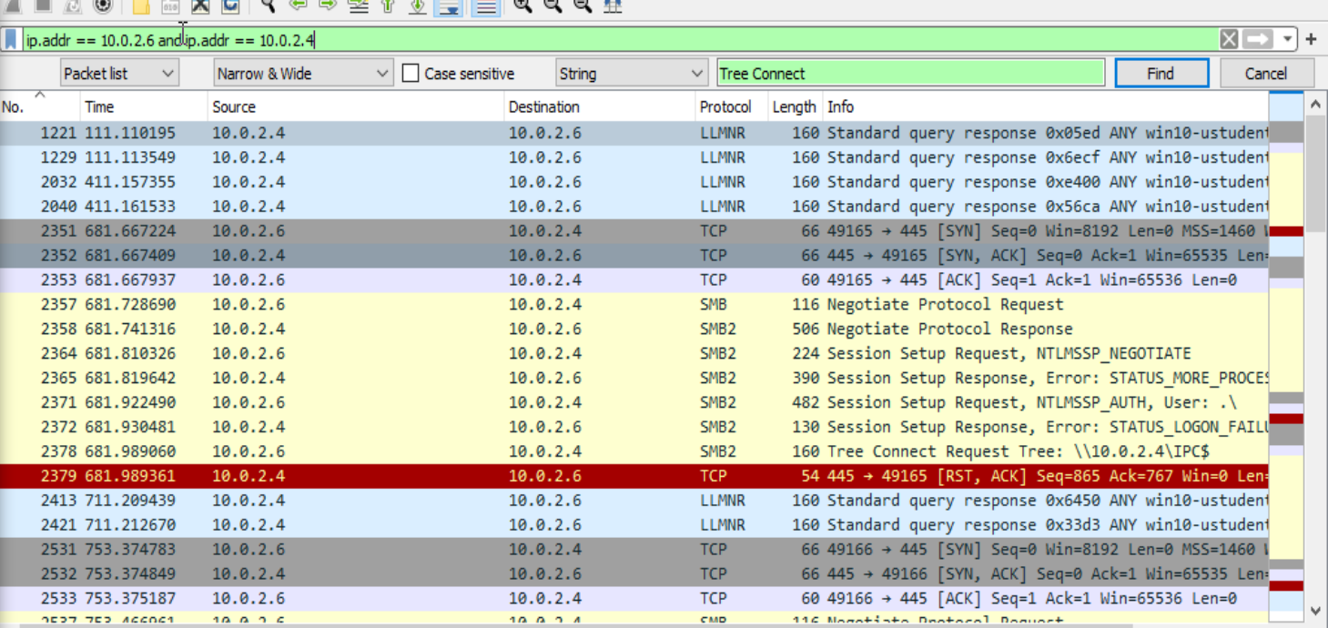

The smb2 protocol on port 445 of 10.0.2.4 is the target.

The attacker 10.0.2.7 was able to read sensitive information. He got access to the payroll_xxxxx.xls file.

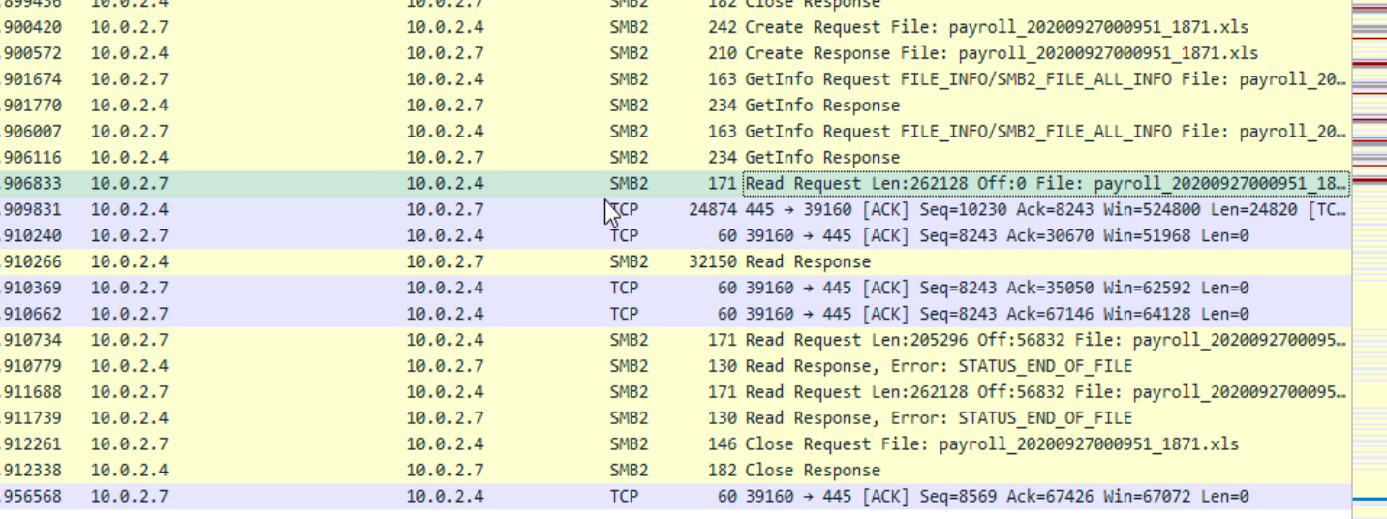

### **Task 3**

Look at logs on the StaticSpeed Windows machine.

Using the logs, determine the following:

* Are there any issues with Windows Share? Please provide screenshots of your findings.
* Look at the audit logs setup at your Linux machine and find the audit.log file. What was the name of the attacker’s account? Please provide screenshots.

Based on what you found above, provide your assessment on whether these events are enough to start an investigation? Please explain your answer based on what you saw in the logs.

I don’t see anything suspicious in the windows event viewer in security tab.

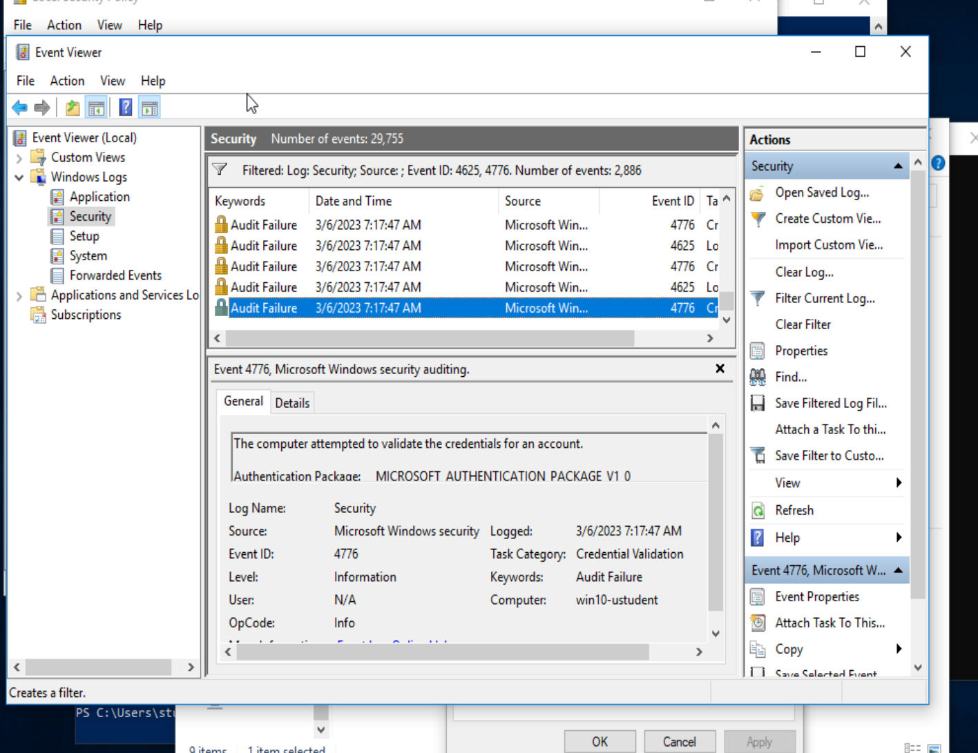

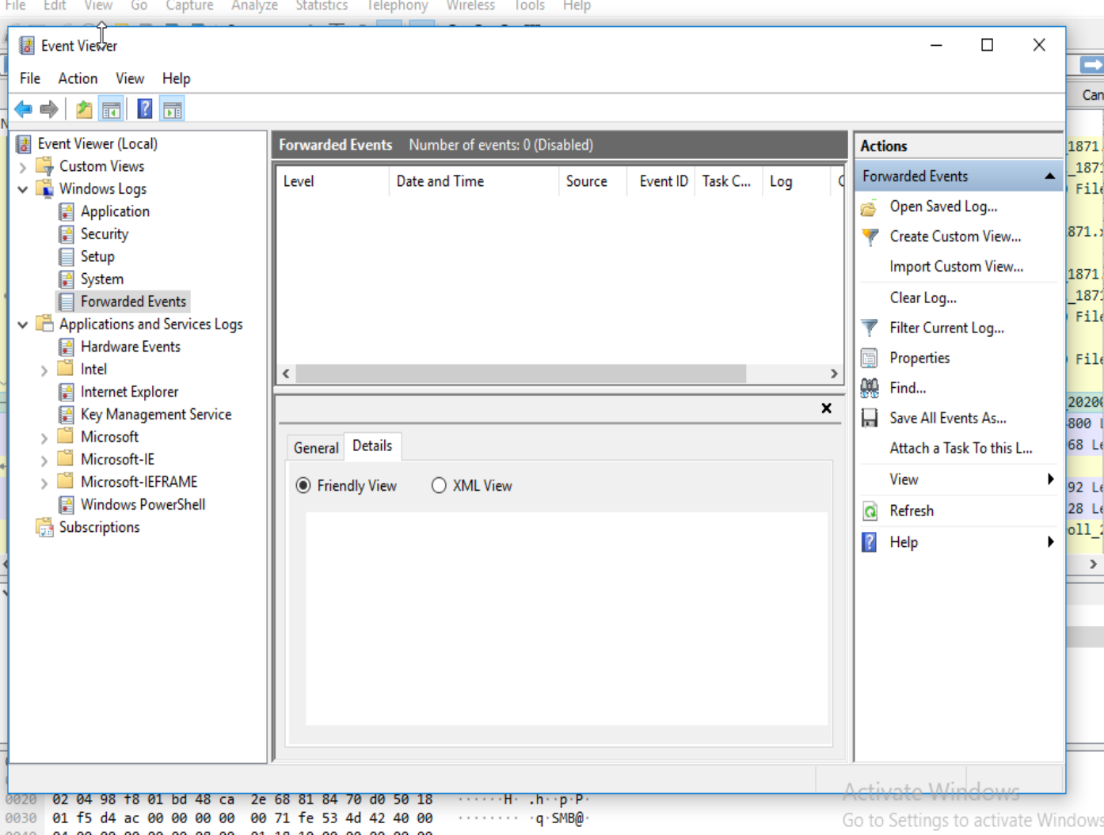

Nothing interesting in forwarding events

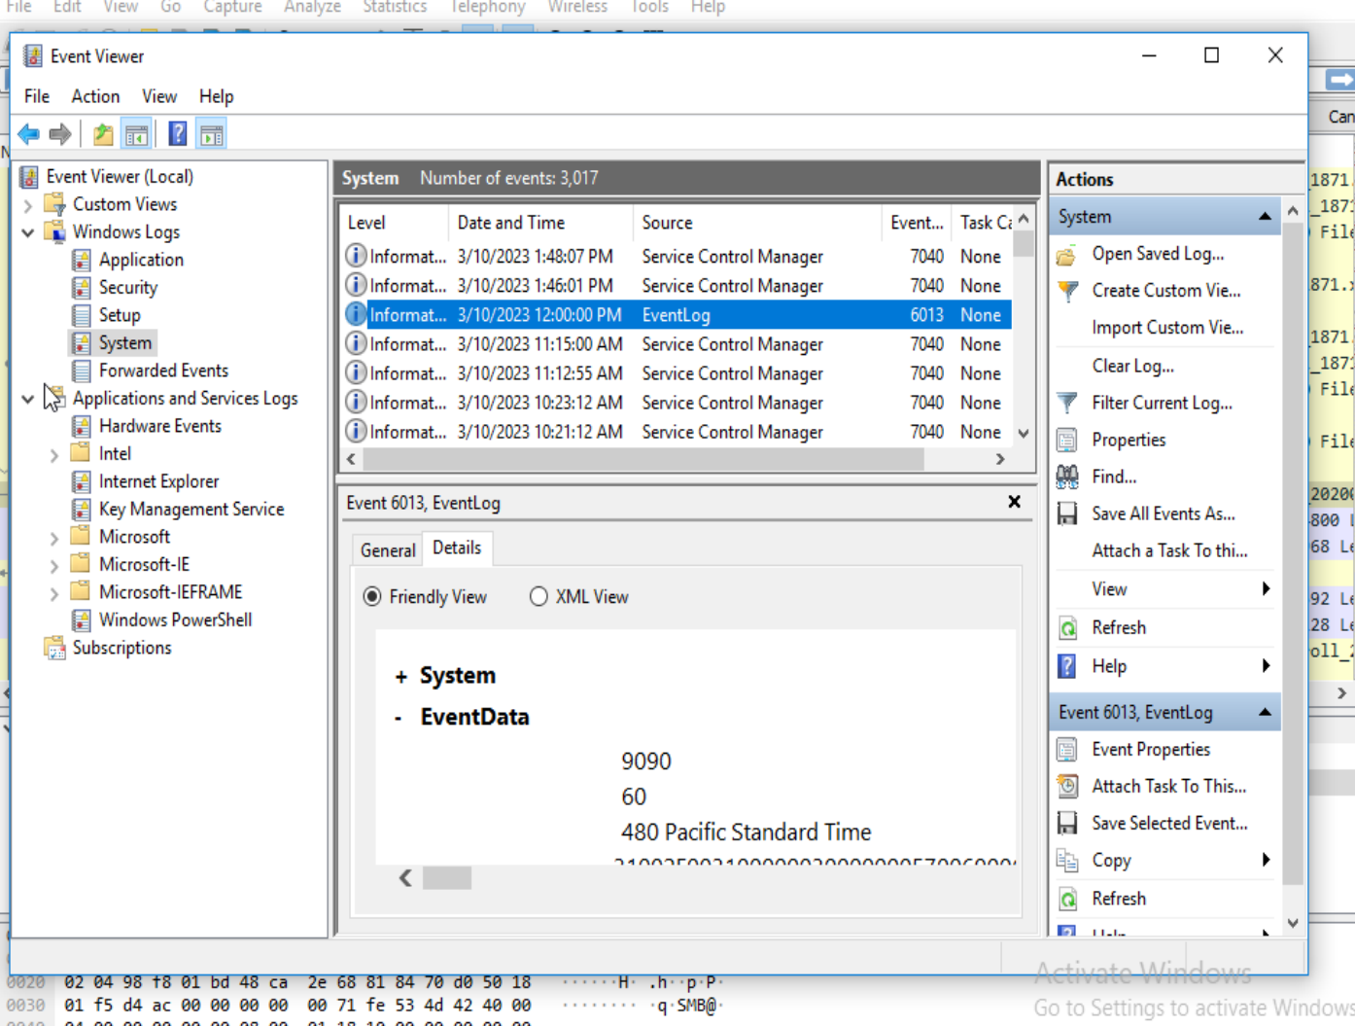

Nothing intersting in system

I also don’t see anything strange in SMB Client and SMB Server

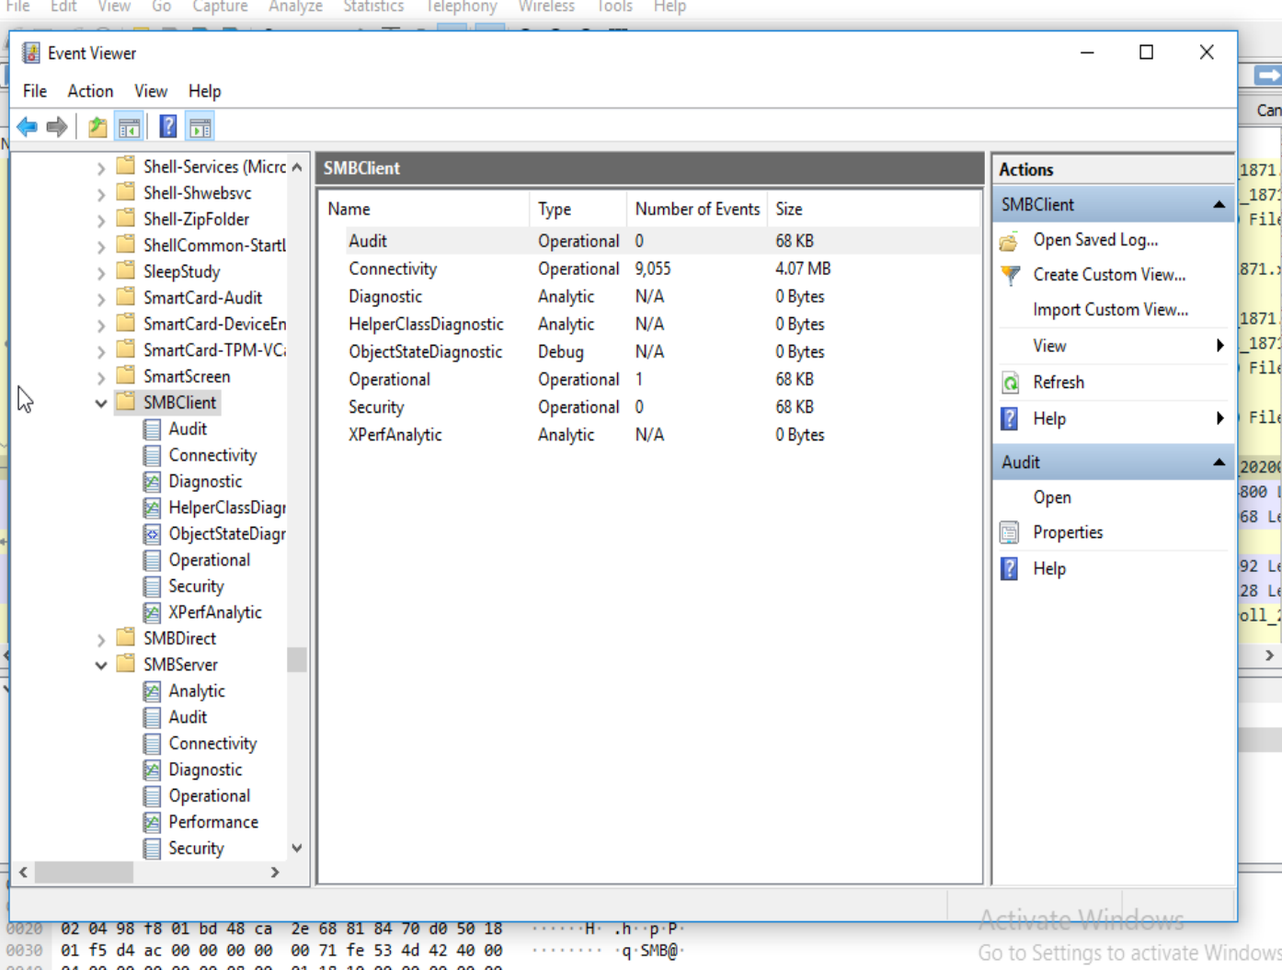

The aureport shows that there are a lot of login attempts with unknown/invalid user names. That could be a possible bruteforce attack. We will check this later.  
The only ones that were abel to login successfully were ustudent and guest. They only have 4 and 1 failed wrong password attempts. Thus they are not part of any brute force attack. Therefore, the assumption is that nothing special happened here.

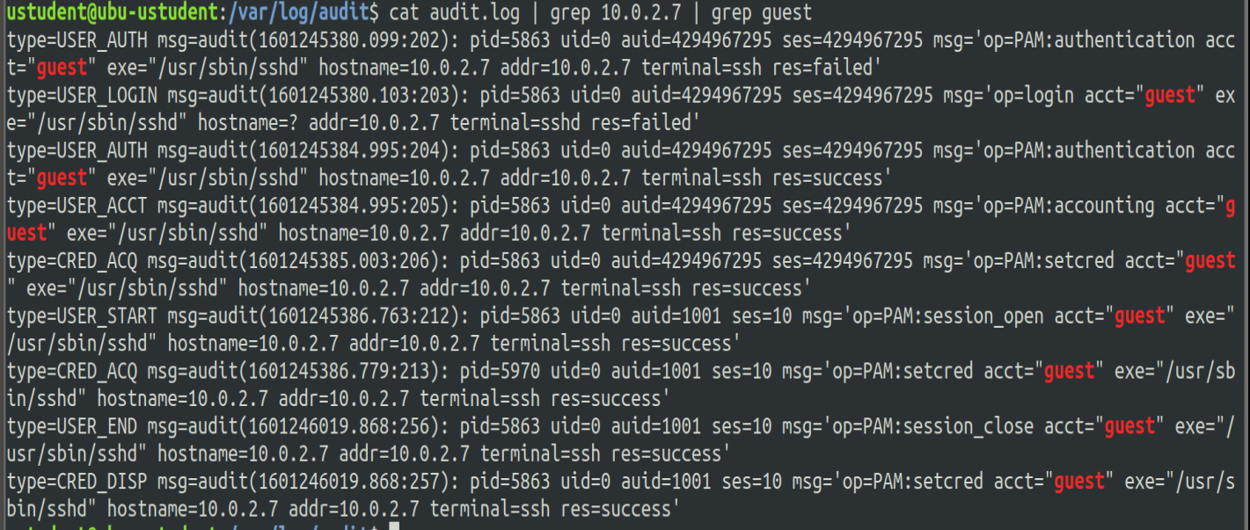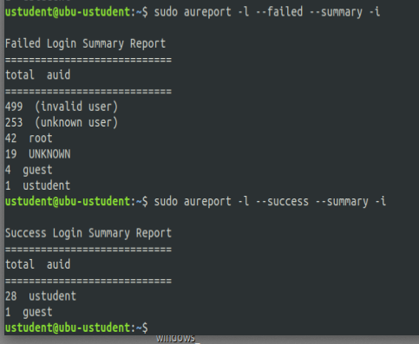

It looks like a bruteforce attack from host 10.0.2.7 as by checking the timeline of the failed attempts we see that there are many attempts with different usernames in a short period of time.

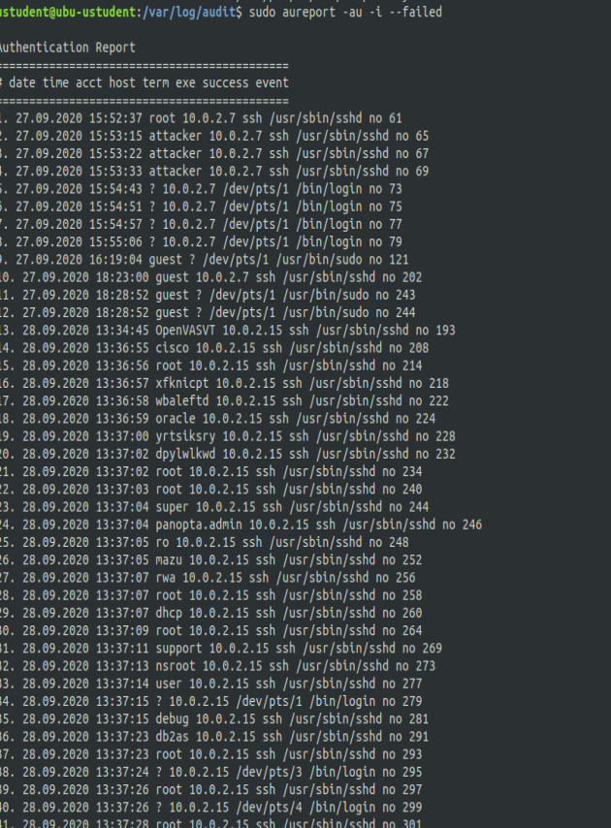

### 

### **Task 4**

NuttyUtility has a centralized log infrastructure using a SIEM product. You need to verify the machines you are checking from StaticSpeed have the settings enabled to use this.

Analyze StaticSpeeds systems and determine if these machines are currently shipping jobs to a centralized location and set up correctly for our SIEM.

Hint: Perform **Ubuntu CIS 4.2.1.3** and verify if remote Syslog is configured for sending logs.

In **Windows,** verify in the event viewer if there are any remote subscriptions related to Windows Event Forwarder.

Based on your answers, suggest a course of action to ensure StaticSpeed meets our needs to use a SIEM.

Ubuntu:

Ubuntu CIS 4.2.1.3 is satisfied.

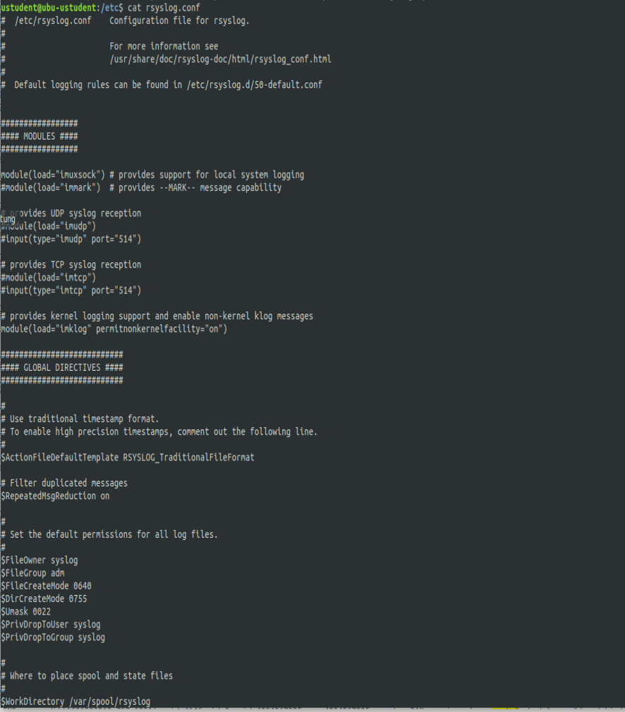

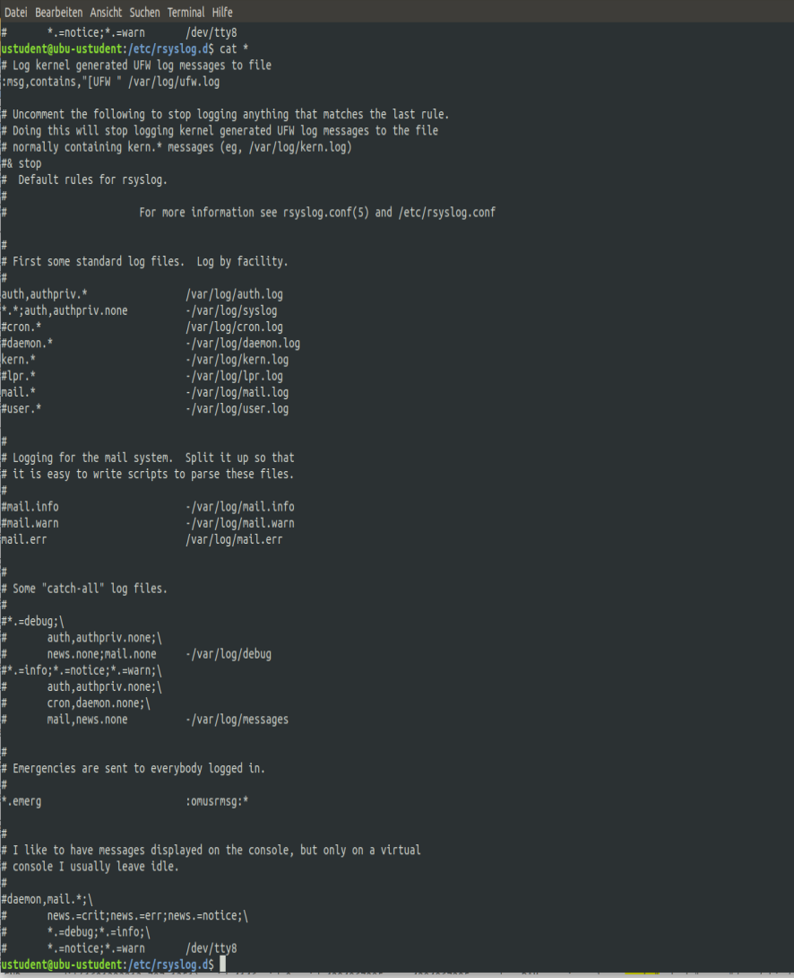

But Ubuntu CIS 4.2.1.5 which checks if rsyslog is configured to send logs to a remote host is not fulfilled. There is no target ip adress where to send the logs to.



## Windows:

I can’t see any subscription in Windows. So it’s not correctly set up.

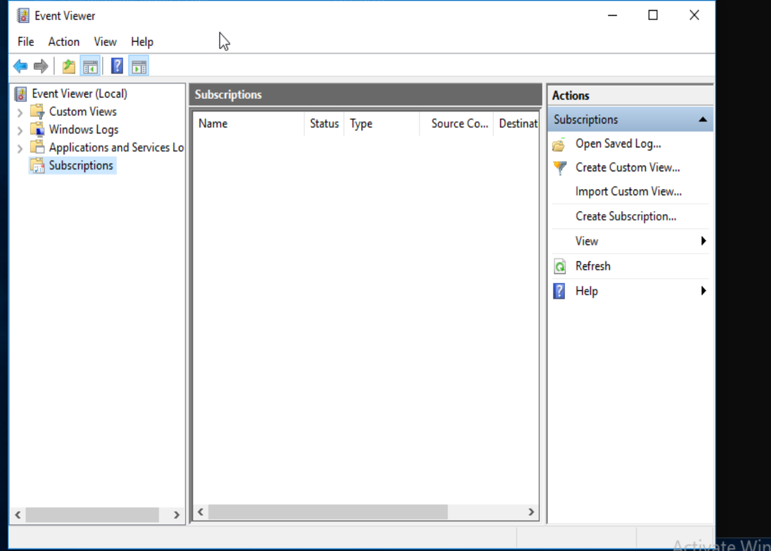

In summary the system is not prepared for using a SIEM. The sending of the logs needs to be configured to be able to use it with a SIM.

## Step 4: Assess Authentication Management at Targeted Assets

### **Task 1**

Evaluate the authentication management situation of StaticSpeed's systems. In our initial look at StaticSpeed, we discovered what is called a "FLAT" network. This means there are no either Active Directory servers or OpenLDAP servers for Linux. We need these to provide us with tools to administer the network and enforce access control models. Specifically, when it comes to separate departments, supervisors, end-users, administrators, contractors, visitors, etc.

We also suspected that anyone that accesses this network could pretty much access everything. Determine if the current authentication scheme at StaticSpeed is unacceptable.

Make sure to include the following:

* Ensure only administrators can remotely access windows machines and verify if root access is permitted at the Linux host.
* Check for users with excessive permissions
* Is root remote login allowed?
* Are there users that should not have remote access via ssh in Linux?
* Remote Desktop Access should only be granted to administrators in Windows, are there other accounts that should not be given access?

Knowing that your company only wants administrators to log remotely, provide a summary of the current situation for StaticSpeed. Then, suggest what accounts should be allowed to log remotely and why. Include your recommendations on whether StaticSpeeds authentication is acceptable and how you would improve it if it is not. Don't forget to include evidence to back up your recommendations.

In ubuntu all users have excessive permissions as discussed earlier. That’s because all are allowed to switch to the superuser(sudo).

In ubuntu ssh root login is disabled by default as a security feature. I don’t see a PermitRootLogin yes in the configuration file. Thus root login is not allowed.

There should be not root access in linux from the outside. It should be restricted to to local ip adresses for root login. Normal users can login. To improve security all users can be denied the access. The only exception is root if they are in the local network.

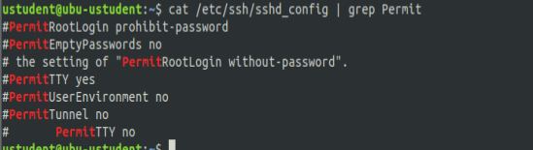

### In Windows Admins as well as normal users can remotely login. To only allow admins to login the remote desktop users should be removed.

### 

### **Task 2**

NuttyUtility follows CIS Benchmarks. Therefore, we need to audit the password policies of StaticSpeed to see if they comply.

Audit the StaticSpeeds systems to verify that they comply with **CIS 5.3.1 Ubuntu** or **Windows 10 CIS benchmarks 1.1.5**? Please provide screenshots of current settings in both systems.

After you perform the checks, please provide an overview of your findings with the specific settings that should be in place and any other changes that should be made. Remember to justify your answer.

**CIS 5.3.1 Ubuntu –Ensure password creation requirements are configured**

The CIS is not fullfilled as can be seen in the screenshot below. The password should be set to minlen = 14 and minclass = 4 or dcredit = -1 ucredit = -1 ocredit = -1 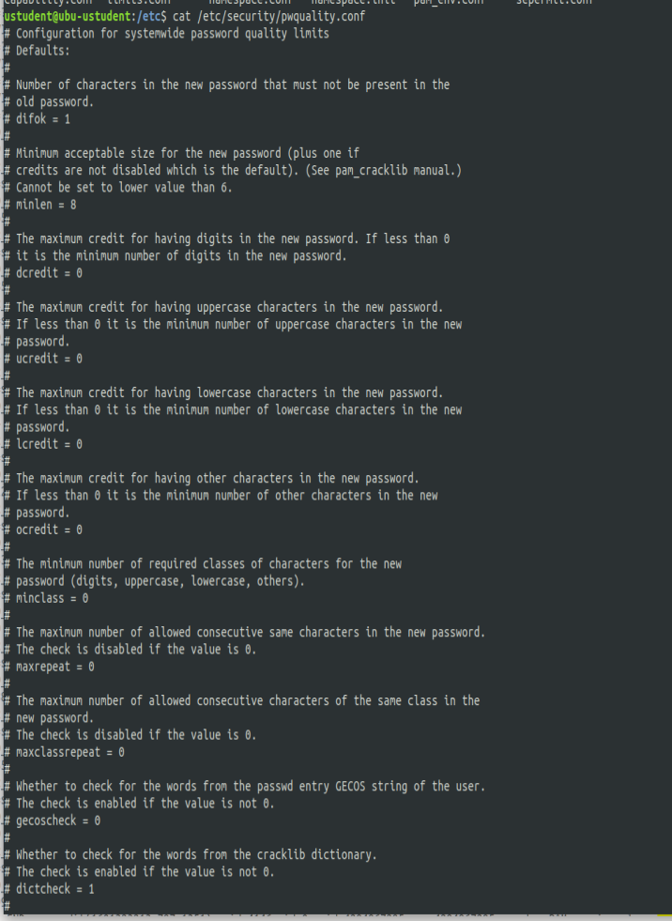lcredit = -1

**Windows 10 CIS benchmarks 1.1.5 – Ensure 'Password must meet complexity requirements' is set to 'Enabled'**

The setting is disabled. It should be enabled to ensure that passwords are secure.

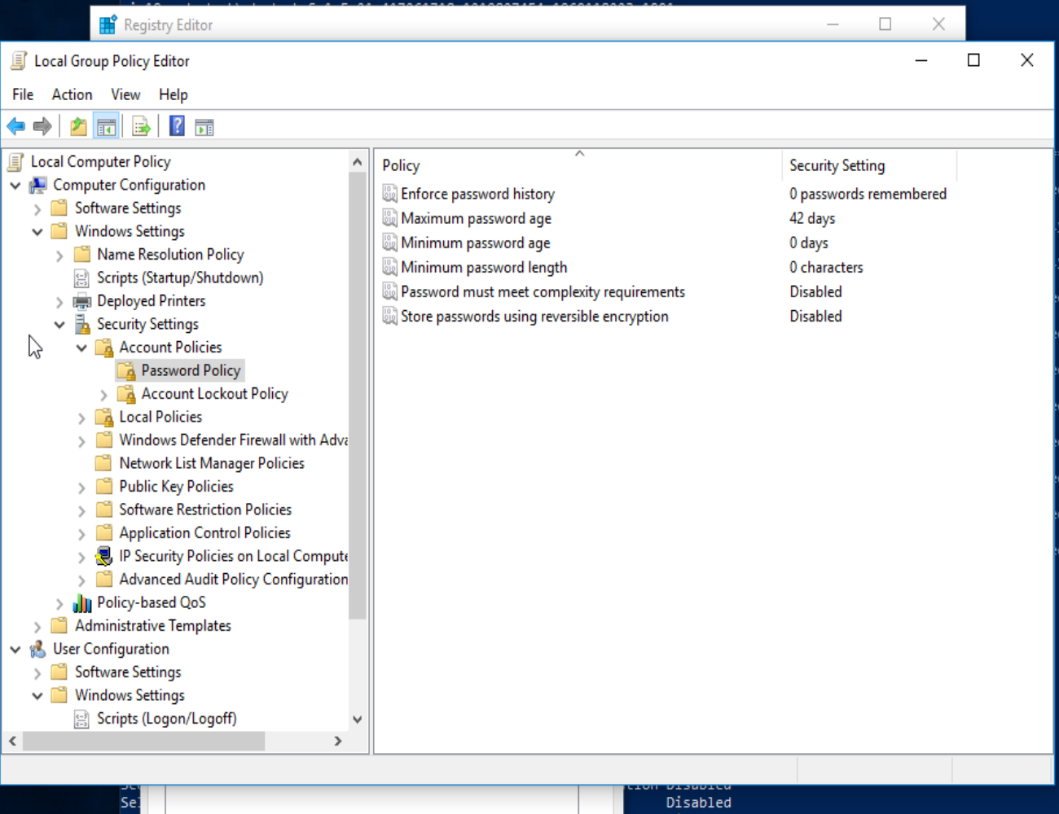

### **Task 3**

NuttyUtility uses a strong encryption ciphers policy (FIPS 140-2). Verify that your target assets comply with this policy. Check that these systems are compliant?. Please provide proof of the checks and give specifics on what to do next to get these systems compliant.

**Ubuntu 18.04 CIS 5.2.13 -**Ensure only strong Ciphers are used

This CIS is fulfilled by the linux machine

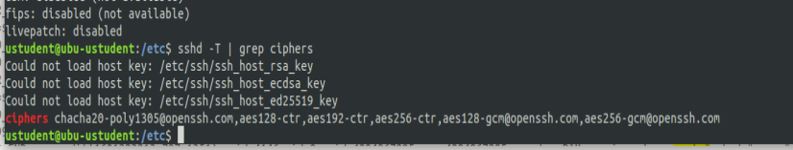

FIPS 140-2 is not installed in ubuntu.

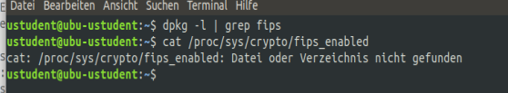

### This link describes how to enable FIPS 140-2: https://ubuntu.com/security/certifications/docs/fips-faq

### 

FIPS is disable in windows. It should be set to enabled

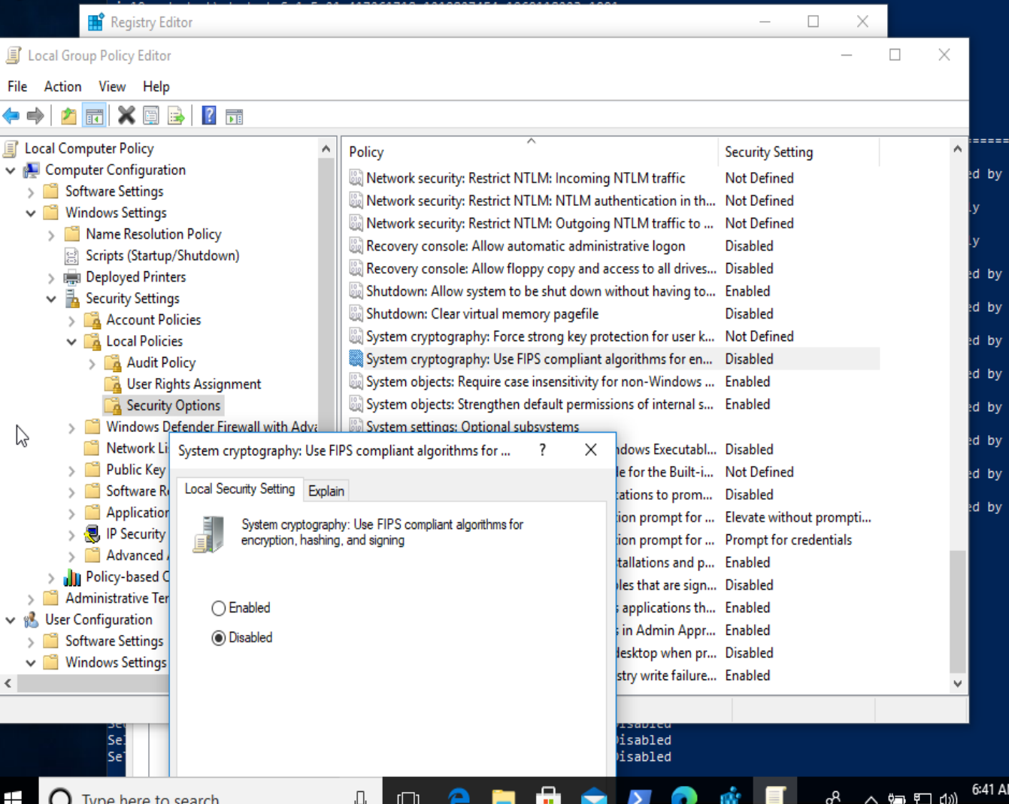

### **Task 4**

**Conduct** aggressive testing for password strength. Use a Nmap NSE Script to test how easy it would be to access StaticSpeed's FTP Server and SMB Shares if an attacker probed them. We have already requested and obtained permission to perform these audits.

Please use an NSE Script to test Mitre ATT&CK T1110 in your Ubuntu virtual machine. Also, use an NSE Script to test the security mode of your SMB shares at your Windows virtual machine. What are your findings? Please provide screenshots. Remember to give an explanation of the security state of these services based on your results.

The ftp server in ubuntu seems to be at least at basic securtiy as the bruteforce attack didn’t return any valid credentials:

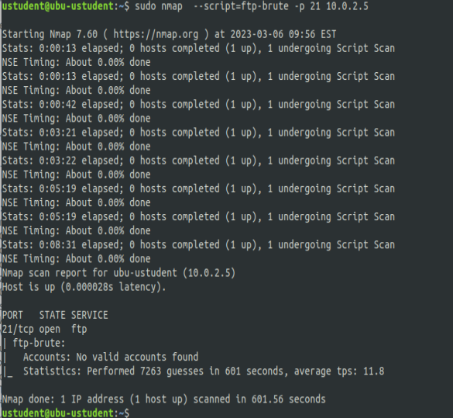

# 

No valid credentials found for smb. Thus it seems at least to be not easily attacked.

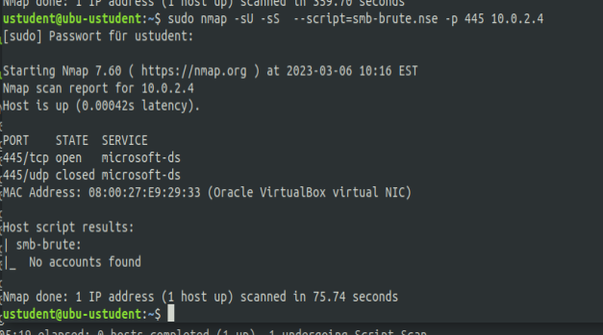

## Step 5: Final Report

After performing the project's tasks, you must produce a report that will include an overview of your findings using the best practices industry format. You are expected to include ALL high, medium, low vulnerabilities, and informational findings (Things that are not necessarily scored but are relevant). Make sure to use and include the scanner switches and vulnerability scripts as they may provide conclusions that are not found in the default scanner settings.

**The format expected for both virtual machine results is below. Please divide by Operating System**

**- Linux Ubuntu 18.04**

- **Windows 10**

### Windows 10 ENT

Ex

|  |  |  |  |  |
| --- | --- | --- | --- | --- |
| Host | High | Medium | Low | Log |
| 10.0.2.4 | 5 | 6 | 1 | 0 |

**IP Address: 10.0.2.4**

|  |  |  |
| --- | --- | --- |
| Service | Port | Sensitive Level |
| Auto Update |  | High |
| Discard Service | 9 tcp | High |
| msrpc | 135 tcp |  |
| netbios-ssn | 139 tcp |  |
| Microsoft ds | 445 tcp |  |
| SEHOP Password Complexity | TCP | Medium |
| Password Quality |  | Medium |
| chargen | 19 tcp | Medium |
| echo | 7 tcp | Medium |
| qotd | 17 tcp | Medium |
| Ms-wbt server | 3389 tcp |  |
| Daytime | 13 tcp | Low |
| xxx | xx TCP | Log |

Expected detail format for vulnerabilities found

The scan shows multiple open ports:

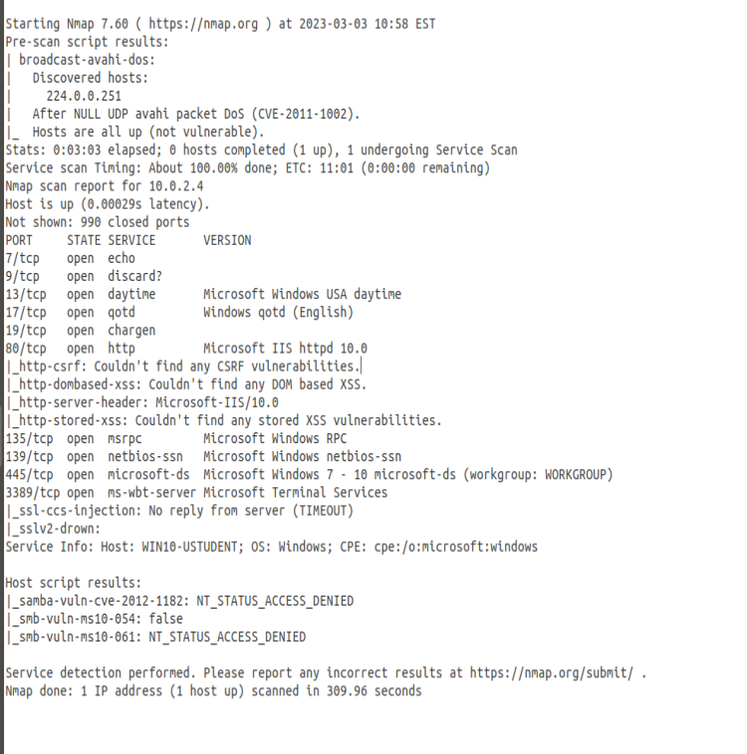

**High - Windows Auto Update is disabled**

**Issue**

Windows is not getting the latest security patches, which makes the system vulnerable



**Impact**

Attackers can exploit the knowledge about known security problems.

**Mitigation**

Windows Auto Update should be enabled

**Reference**

Windows CIS 18.9.102.2

**High - CVE-1999-0636 – Discard Service Running**

**Issue**

The discard service is running

**Impact**

Using a weakness in discard service users can elevate privileges. The attack is described in Das MITRE ATT&CK Projekt deklariert die Angriffstechnik als [T1068](https://vuldb.com/de/?vulnerability_attck.14400).

**Mitigation**

Disable the discard service

**Reference**

https://www.cvedetails.com/cve/CVE-1999-0636/

<https://vuldb.com/de/?id.14400>

**High - CVE-CVE-2022-26809 – msrpc Service**

**Issue**

An integer overflow in MSRPC that, if exploited, allows for arbitrary code execution over the network without requiring authentication or user interaction.

**Impact**

The attacker can perform code execution which is very critical

**Mitigation**

According to Microsoft “The known attack that was presented to Microsoft does not use TCP Port 135 to initiate an exploit but, as the vulnerability is in RPC, blocking TCP port 135 at the enterprise perimeter firewall is a recommended best practice that would reduce the likelihood of other potential attacks against this vulnerability.”

Otherwise service should be patched

**Reference**

https://msrc.microsoft.com/update-guide/vulnerability/CVE-2022-26809

**High - CVE-CVE-2022-26809 – netbios-ssn**

**Issue**

Ports 139 and 445 are used for ‘NetBIOS’ communication between two Windows 2000 hosts. In the case of port 445 an attacker may use this to perform NetBIOS attacks as it would on port 139.

**Impact**

The attacker can perform code execution which is very critical

**Mitigation**

The ports should be disabled

**Reference**

**https://support.microsoft.com/en-us/topic/preventing-smb-traffic-from-lateral-connections-and-entering-or-leaving-the-network-c0541db7-2244-0dce-18fd-14a3ddeb282a**

**High - CVE-CVE-2022-26809 – Microsoft Ds**

**Issue**

Ports 139 and 445 are used for ‘NetBIOS’ communication between two Windows 2000 hosts. In the case of port 445 an attacker may use this to perform NetBIOS attacks as it would on port 139.

**Impact**

The attacker can perform code execution which is very critical

**Mitigation**

The ports should be disabled

**Reference**

[**https://support.microsoft.com/en-us/topic/preventing-smb-traffic-from-lateral-connections-and-entering-or-leaving-the-network-c0541db7-2244-0dce-18fd-14a3ddeb282a**](https://support.microsoft.com/en-us/topic/preventing-smb-traffic-from-lateral-connections-and-entering-or-leaving-the-network-c0541db7-2244-0dce-18fd-14a3ddeb282a)

**High - CVE-CVE-2022-26809 – msrpc Service**

**Issue**

**Impact**

**Mitigation**

**Reference**

**Medium - Enable Structured Exception Handling Overwrite Protection (SEHOP)' is disabled**

**Issue**

[At a high-level, the SEH overwrite technique uses a software vulnerability to execute arbitrary code by abusing the 32-bit exception dispatching facilities provided by Windows.](https://msrc.microsoft.com/blog/2009/02/preventing-the-exploitation-of-structured-exception-handler-seh-overwrites-with-sehop/)

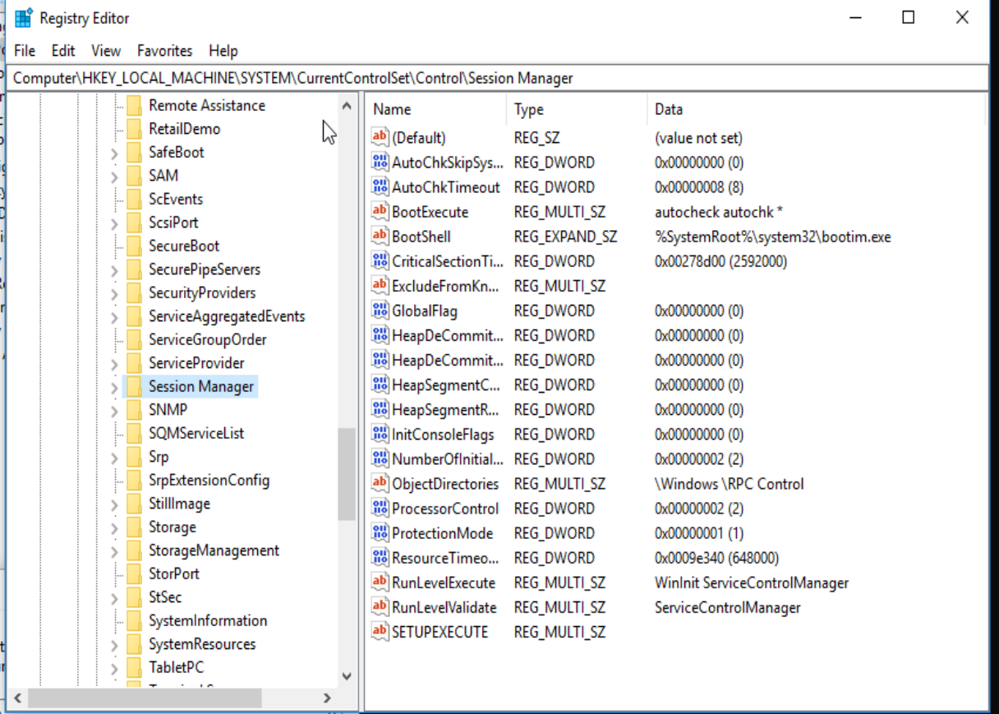

**Impact**

This feature is designed to block exploits that use the Structured Exception Handler (SEH) overwrite technique.

**Mitigation**

Set it to enabled. Just follow CIS 18.3.4

**Reference**

Windows CIS 18.3.4.

**Medium - Ensure 'Password must meet complexity requirements' is set to 'Enabled'**

**Issue**

There is no check that passwords contain a minimum complexity. If a weak password is chosen the attacker has an easy game.



**Impact**

An attacker can easily brutefore the password.

**Mitigation**

Follow the instructions of Windows 10 CIS benchmarks 1.1.5 and set the flag to enabled.

**Reference**

Windows 10 CIS benchmarks 1.1.5

**Medium - CVE-1999-0103 - Chargen Service can be exploited**

**Issue**

The chargen service can be used for denial of service attacks.

**Impact**

The attacker can flood the server and make it unavailable. It furthermore can be used as an intermediate server for causing the attack.

**Mitigation**

The chargen service should be disabled

**Reference**

**https://www.cvedetails.com/cve/CVE-1999-0103/**

https://www.incibe-cert.es/en/blog/chargen-cyberattacks-based-chargen-protocol

**Medium - CVE-1999-0103 - Echo Service can be exploited**

**Issue**

The echo service can be used for denial of service attacks.

**Impact**

The attacker can flood the server and make it unavailable. It furthermore can be used as an intermediate server for causing the attack.

**Mitigation**

The echo service should be disabled

**Reference**

<https://www.cvedetails.com/cve/CVE-1999-0103/>

<https://www.incibe-cert.es/en/blog/chargen-cyberattacks-based-chargen-protocol>

**Medium- CVE-1999-0103 – QOTD Service Running**

**Issue**

Remote Code Execution Vulnerability

**Impact**

A remote code execution vulnerability exists in Remote Desktop Services formerly known as Terminal Services when an unauthenticated attacker connects to the target system using RDP and sends specially crafted requests, aka 'Remote Desktop Services Remote Code Execution Vulnerability'.

**Mitigation**

Disable the service

**Reference**

<https://cve.mitre.org/cgi-bin/cvename.cgi?name=CVE-2019-0708>

**Medium- CVE-2019-0708 - MS Terminal Services Running**

**Issue**

The qotd service is running.

**Impact**

The qotd service can be used to flood the server with a bomb or packet storm.

**Mitigation**

Disable the service

**Reference**

https://www.cvedetails.com/cve/CVE-1999-0103/

**Low- CVE-1999-0638 – Daytime Service Running**

**Issue**

The daytime service is running.

**Impact**

The daytime service is an unsecured and obsolete protocol and it should be disabled.

**Mitigation**

Should be disabled

**Reference**

<https://nvd.nist.gov/vuln/detail/CVE-1999-0638>

### Ubuntu 18.04

Ex

|  |  |  |  |  |
| --- | --- | --- | --- | --- |
| Host | High | Medium | Low | Log |
| 10.0.2.5 | 3 | 3 | 2 | 1 |

**IP Address: 10.0.2.5**

|  |  |  |
| --- | --- | --- |
| Service | Port | Sensitive Level |
| ftp | 21 tcp | High |
| ssh | 22 tcp | High |
| telnet | 23 tcp | High |
| netbios-ssn | 139 tcp | HIgh |
| netbios-ssn | 445 tcp | High |
| http | 80 tcp | Medium |
| http | 80 tcp | Medium |
| qotd | 17/tcp | Medium |
| Daytime | 13/tcp | Low |
| ASLR |  | Low |
|  |  |  |

Scan Results of Ubuntu:

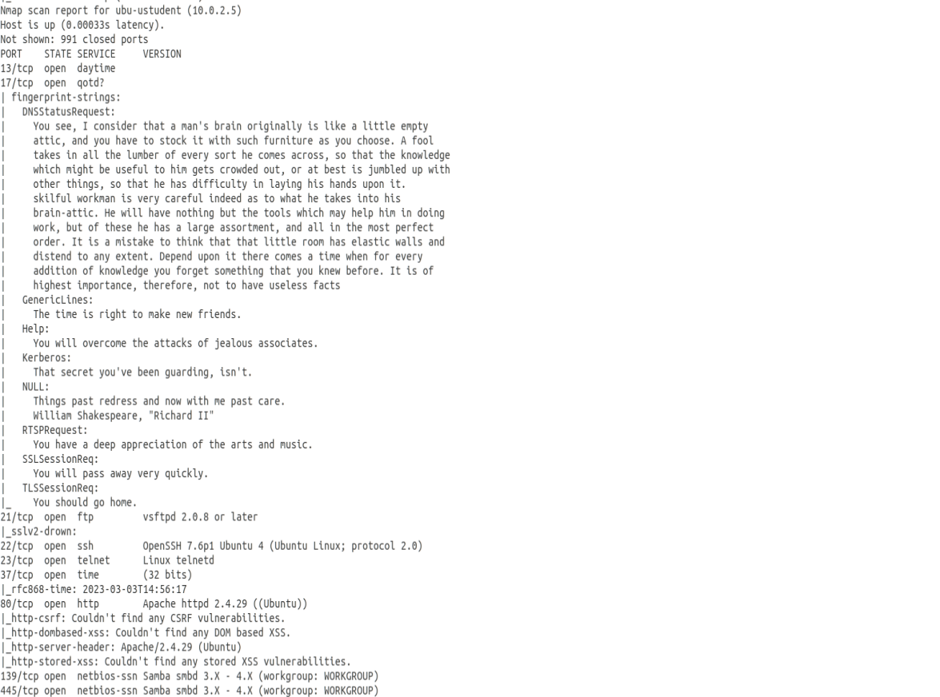

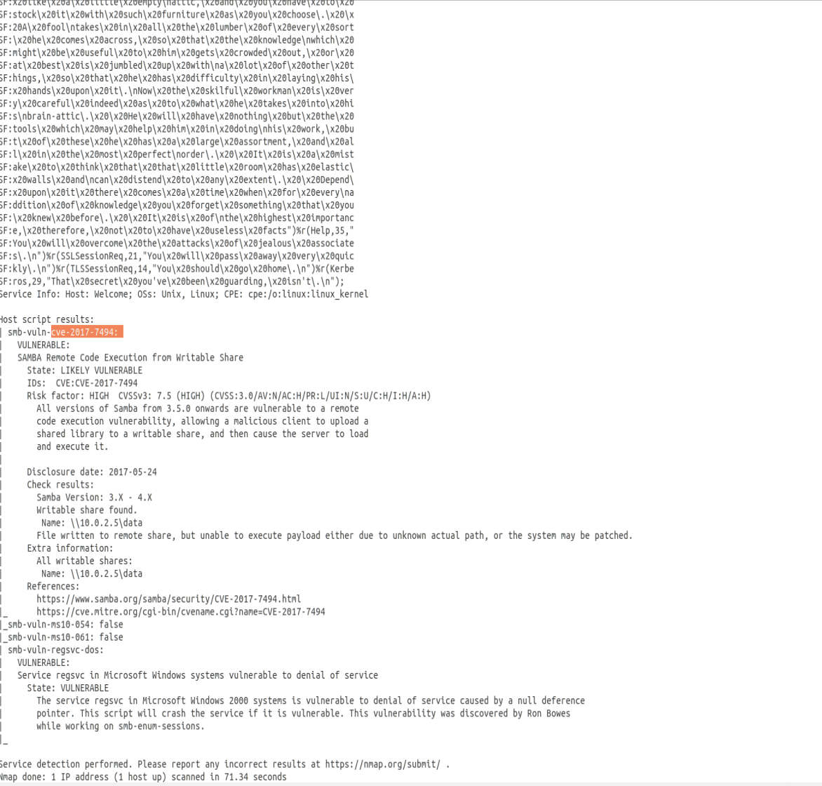

**High - ftp - CVE-2011-2523**

**Issue**

vsFTPd contains a backdoor which opens a shell on port 6200/tcp.

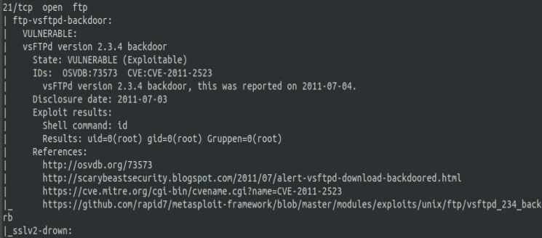

**Impact**

The attacker can open a shell and then is able to takeover full control

**Mitigation**

In general ftp should be disabled due to this and other problems. It should be replaced by a more secure service.

**Reference**

<https://nvd.nist.gov/vuln/detail/CVE-2011-2523>

**High - ssh - CVE-2021-41617**

**Issue**

ssh runs in an old version OpenSSH 7.6

**Impact**

sshd in OpenSSH 6.2 through 8.x before 8.8, when certain non-default configurations are used, allows privilege escalation because supplemental groups are not initialized as expected. Helper programs for AuthorizedKeysCommand and AuthorizedPrincipalsCommand may run with privileges associated with group memberships of the sshd process, if the configuration specifies running the command as a different user.

**Mitigation**

Update to the newest version of OpenSSH

**Reference**

<https://nvd.nist.gov/vuln/detail/CVE-2021-41617>

**High - Telnet Unencrypted Cleartext Login**

**Issue**

The host is running a Telnet service that allows cleartext logins over unencrypted connections



**Impact**

Attackers can uncover login names and passwords by sniffing traffic to the Telnet service.

**Mitigation**

Replace Telnet with remote access protocols that support encryption such as SSH.

**Reference**

<https://attack.mitre.org/techniques/T1021/>

**High - CVE-2017-7494 – netbios-ssn**

**Issue**

Ports 139 and 445 are used for ‘NetBIOS’ communication between hosts. In the case of port 445 an attacker may use this to perform NetBIOS attacks as it would on port 139.

**Impact**

The attacker can perform code execution which is very critical

**Mitigation**

The ports should be disabled

**Reference**

[**https://support.microsoft.com/en-us/topic/preventing-smb-traffic-from-lateral-connections-and-entering-or-leaving-the-network-c0541db7-2244-0dce-18fd-14a3ddeb282a**](https://support.microsoft.com/en-us/topic/preventing-smb-traffic-from-lateral-connections-and-entering-or-leaving-the-network-c0541db7-2244-0dce-18fd-14a3ddeb282a)

**High - CVE-2017-7494 – netbios-ssn**

**Issue**

Ports 139 and 445 are used for ‘NetBIOS’ communication between hosts. In the case of port 445 an attacker may use this to perform NetBIOS attacks as it would on port 139.

**Impact**

The attacker can perform code execution which is very critical

**Mitigation**

The ports should be disabled

**Reference**

[**https://support.microsoft.com/en-us/topic/preventing-smb-traffic-from-lateral-connections-and-entering-or-leaving-the-network-c0541db7-2244-0dce-18fd-14a3ddeb282a**](https://support.microsoft.com/en-us/topic/preventing-smb-traffic-from-lateral-connections-and-entering-or-leaving-the-network-c0541db7-2244-0dce-18fd-14a3ddeb282a)

**Med - http - CVE-2018-17189**

**Issue**

In Apache HTTP server versions 2.4.37 and prior, by sending request bodies in a slow loris way to plain resources, the h2 stream for that request unnecessarily occupied a server thread cleaning up that incoming data.

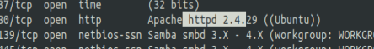

**Impact**

The server resources are lowered

**Mitigation**

The version of apache should be upgraded

**Reference**

<https://www.cvedetails.com/cve/CVE-2018-17189/>

**Med - http - CVE-2018-1312**

**Issue**

In Apache httpd 2.2.0 to 2.4.29, when generating an HTTP Digest authentication challenge, the nonce sent to prevent reply attacks was not correctly generated using a pseudo-random seed.

**Impact**

In a cluster of servers using a common Digest authentication configuration, HTTP requests could be replayed across servers by an attacker without detection.

**Mitigation**

upgrade the versioin of apache

**Reference**

https://www.cvedetails.com/cve/CVE-2018-1312/

**Med- CVE-1999-0103 – QOTD Service Running**

**Issue**

The qotd service is running.

**Impact**

The qotd service can be used to flood the server with a bomb or packet storm.

**Mitigation**

Disable the service

**Reference**

<https://www.cvedetails.com/cve/CVE-1999-0103/>

**Low- CVE-1999-0638 – Daytime Service Running**

**Issue**

The daytime service is running.

**Impact**

The daytime service is an unsecured and obsolete protocol and it should be disabled.

**Mitigation**

Should be disabled

**Reference**

<https://nvd.nist.gov/vuln/detail/CVE-1999-0638>

**Low Ensure address space layout randomization (ASLR) is enabled**

**Issue**

An attacker can examine the layout of an program and thus can use memory exploits

**Impact**

In a cluster of servers using a common Digest authentication configuration, HTTP requests could be replayed across servers by an attacker without detection.

**Mitigation**

Follow the steps of CIS 1.6.2 and activate ASLR. Randomly placing virtual memory regions will make it difficult to write memory page exploits as the memory placement will be consistently shifting

**Reference**

Ubuntu CIS 1.6.2

## Step 6: Final Assessment and Recommendations Based on Your Scans and Checks

In this section, provide a final recommendation, supported by the information above, on whether NuttyUtility should extend its network and integrate the StaticSpeed system into its current infrastructure.

Include the following in your assessment:

- Would integrating this network into the extended network of our company bring new risks and exposures?

- If it would be a risk to NuttyUtility, what recommendations would you make to mitigate these risks before implementing the integration, and why?

- Please provide reasoning based on the proof obtained throughout your assessment.

- Remember, the Stakeholders need to decide as to whether or not to complete this integration now.

**The final recommendation is not to include the StaticSpeed System**

The table above shows that there are multiple vulnerabilities with a high criticality are found. In general it can be seen that the current system does not fulfill the the security standards that are needed to include it.

There were only a few CIS checked that failed the audition. Thus, it is recommend to go through the whole list of CIS and for each disabled one check if that’s really what we want.

The next steps would be to fix all the issues mention in this report. Afterwards a new scan should be made to check if there are other findings that are not already mentioned yet due to the high number of issues.